Boss Battle 1.4.4u (06.08.21)  
_________________________________________________________

 - Made with community feedback.



[Discord server](https://discordapp.com/invite/KVfrcby)



[Database](https://docs.google.com/spreadsheets/d/1EKDcst62EP95DTYc0IeDh3wD8KcniLSq-fCki92ytxQ/edit#gid=1199919977)



[PayPal](https://www.paypal.me/bbwc3)



[Patreon](https://www.patreon.com/bbwc3)

**ITEMS**

______________________________



- Ring of Addiction: Chance: 50%=>40%.



- Majyte: Spell power per cast: 100%=>150%.



- Sundial: Chance: 2%=>8%.

**BOSSES**

______________________________



- Poisonous evil: The effect of death on damage has been removed. Added a new effect: "When someone dies, the boss deals 150 damage to all enemies in a large area.".

**BONUSES**

______________________________



- Chaos Earring: Effect changed: "Every third fight, improves uniques until the end of the fight."

**OTHER**

______________________________

- Arena rune models have been changed.

- Added a new skin: Combat ogre (lv.24).

Boss Battle 1.4.4t (02.08.21)  
_________________________________________________________

 - Made with community feedback.



[Discord server](https://discordapp.com/invite/KVfrcby)



[Database](https://docs.google.com/spreadsheets/d/1EKDcst62EP95DTYc0IeDh3wD8KcniLSq-fCki92ytxQ/edit#gid=1199919977)



[PayPal](https://www.paypal.me/bbwc3)



[Patreon](https://www.patreon.com/bbwc3)

**ITEMS**

______________________________

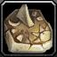

- World clock: Rarity: Legendary=>Rare.



- Runestone Glas: Spell Power per potion: 5%=>3%.



- Chameleon Eye: Now reduces uniques spell power by 25%.



- Thief's Gloves: Gold per hit: 2=>3.



- Enchanted Thorium: The probability bonus has been doubled.



- Soul Crystal: Souls no longer disappear at the end of combat.



- Camouflage paint: Rarity: Rare=>Common.

**HEROES**

______________________________



- Shoggoth:

Writhing Mass: Chance: 20%=>40%.



- Armsmaster:

Opportunistic Reflexes: Chance: 8%/11%/14%/17%/20%=>6%/8%/10%/12%/14%.



- Bone Knight:

Horror: Duration: 8/10/12/14/16=>6/8/10/12/14.



- Living Altar:

Blood Mend: Cooldown: 8=>10.



- Money Bag:

Digest: Cooldown: 20=>14.



- Wanderer:

Veritus Mortuus: Cooldown: 4=>6.



- Vampire:

Blood splash: Cooldown: 4=>5.

True form: Cost: 150=>300.

**BONUSES**

______________________________



- Curse: Scatter: "When the enemy dies, deal 100 damage to all enemies of the creature."

**OTHER**

______________________________

- Added 2 new specials.

- Added new skins: Combat Ogre (lv.9), Pyrolord (lv. 14), Commander (lv.21), Grim Ninja (lv.22).

- Added a new UI element to quickly select a Jule's store.

**BUGS**

______________________________

- Fixed an issue that prevented the "Self-Sacrifice" ability to activate the cooldown when using the ability.

- Fixed an issue where resurrecting a player in a berserk mode state would cause the game to stop working.

- Fixed an issue that caused the "Chameleon Eye" artifact to work incorrectly when changing souls.

- Fixed an issue that caused the "Time rift" special to work incorrectly when changing souls.

- Fixed an issue where receiving an item during the Pandora's Box artifact effect, which was not an artifact of your choice, would terminate the artifact effect.

- Fixed an issue that prevented the "Bloody Figurine" artifact from working with the "Crystal" set bonus.

- Fixed an issue where Channel Energy might not remove the visual effect of lightning when casting an ability on a target that was already affected.

- Fixed an issue that caused the "Salamander" boss to keep moving while under the effect of the "Vine Trap" artifact.

Boss Battle 1.4.4r (25.07.21)  
_________________________________________________________

 - Made with community feedback.



[Discord server](https://discordapp.com/invite/KVfrcby)



[Database](https://docs.google.com/spreadsheets/d/1EKDcst62EP95DTYc0IeDh3wD8KcniLSq-fCki92ytxQ/edit#gid=1199919977)



[PayPal](https://www.paypal.me/bbwc3)



[Patreon](https://www.patreon.com/bbwc3)

**ITEMS**

______________________________

- Added a new items:

|  | Unique Recipe Book | Alchemy. Ring. Uniques spell power also increases potion spell power by 50% of its current power. Increases uniques spell power by 50%. |
| --- | --- | --- |
|  | Runestone Kusa | Rune. Reduces the cooldown of abilities and items by 40%. When the hero uses an ability or item, silences for 5 seconds. |
|  | Bonus Collector | Mech. When you take an artifact with [Random bonus], it gives 2 extra ones. Random bonus. Random bonus. |
|  | Rigged Dice Set | Doubles the base proc chance bonus for all **luck**-based effects. |
|  | Corrupted Wish | Activation: Corrupted. Gives 3 corrupted artifacts to empty inventory slots. |
|  | Coal Gift | Activation: Corrupted. Forges a corrupted artifact. |
|  | Treasure Map | At least one artifact-reward will be corrupted. Activation: Corrupted. Gives a random bonus for each your corrupted artifact used in this game. |
|  | Runestone Brib | Rune. Reduces the cost of Jule artifacts by 20%. At least one artifact from Jule will be discounted. Items not obtained from Jule will be cursed. |
|  | Runestone Gnir | Rune. Increases spell power of uniques by 150%. Increases cooldown of abilities and items by 15%. |
|  | Runestone Glas | Rune. Increases spell power by 5% for each potion you use during the game. Reduces potion spell power by 50%. |



- Splitting the World: Requirement for the quest: 15=>10.



- Scorching mash: Intoxication: Now uses a random level 5 ability, instead of 1.



- Santa's Bag: Now works in combat.

**HEROES**

______________________________

- Added a new hero: Peacelock (Elementalist).

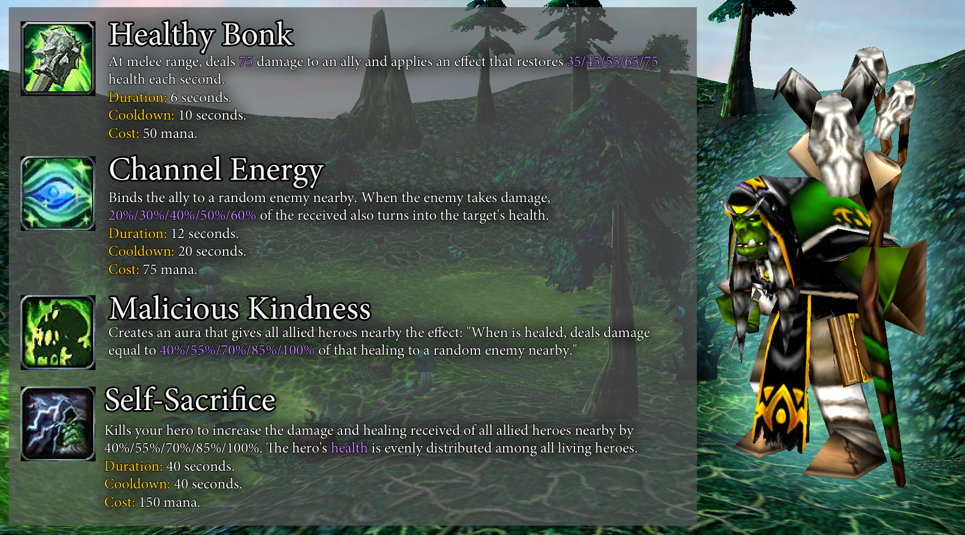

**BOSSES**

______________________________



- Manipulator: At 80%: Zones now burn 4% mana, instead of 10 points.

**OTHER**

______________________________

- [Experimental] Forge mechanics now work in combat.

- Added a new skin: Troll mage (lv.23).

- Unstable Potions: Potion lifetime: 5=>4.

- Arena runes that restore health and mana now only work for heroes.

- Added interface to track current spell power for potions and uniques.

**BUGS**

______________________________

- Fixed an issue that caused the "Space Distortion" and "Abyssal Decimation" abilities to work incorrectly with player skins when changing souls.

- Fixed a bug that caused 3 "Ring of Identity" artifacts to give all sets instead of 3 for a non-red player.

Boss Battle 1.4.4p (19.07.21)  
_________________________________________________________

[Discord server](https://discordapp.com/invite/KVfrcby)

[Database](https://docs.google.com/spreadsheets/d/1EKDcst62EP95DTYc0IeDh3wD8KcniLSq-fCki92ytxQ/edit#gid=1199919977)

[PayPal](https://www.paypal.me/bbwc3)

[Patreon](https://www.patreon.com/bbwc3)

 - Made with community feedback.

**ITEMS**

______________________________

- Added new items:

|  | Refresher | Activation: Corrupted. Increases health by 10. Changes artifact rewards to other ones. 10 charges. |
| --- | --- | --- |
|  | VIP card | Activation: Corrupted. Increases stats by 1. Improves the assortment of goods at Jule. |

- Added a new quest.



- Blacksmith craft: Requirement for the quest: 4=>5.



- Insatiable flame: Cost reduction: 3=>5. Cooldown: 45=>30.



- Rubedo's Belt: Chance: 50%=>100%. No longer has a random bonus. The artifact has been removed from the legendary artifact rotation.



- Phoenix Badge: Rarity: Legendary=>Rare.



- Learning Curve: Rarity: Common=>Rare.



- Pig in a poke: Effect changed: "Corrupted. You get all your artifact rewards (if there are free slots in your inventory)."

**HEROES**

______________________________



- Chronomancer:

Distortion: Learning an ability no longer resets the cooldown of all abilities and items.



- Toxic Elemental:

Raging Bane: Added an additional overlay effect: "Damage from Quicksilver Vapors and Deadly Venom to you restores health instead."

**OTHER**

______________________________

- Heroes controlled by the boss now have the lowest priority for attacking the bosses and their minions.

- Added "-autoload" test command which automatically downloads progress on unsuccessful attempt.

**BUGS**

______________________________

- Fixed incorrect attack animation for "Troll Mage" skin.

Boss Battle 1.4.4o (10.07.21)  
_________________________________________________________

[Discord server](https://discordapp.com/invite/KVfrcby)

[Database](https://docs.google.com/spreadsheets/d/1EKDcst62EP95DTYc0IeDh3wD8KcniLSq-fCki92ytxQ/edit#gid=1199919977)

[PayPal](https://www.paypal.me/bbwc3)

[Patreon](https://www.patreon.com/bbwc3)

 - Made with community feedback.

**ITEMS**

______________________________

- Added new items:

|  | Pandora's Box | Activation: Corrupted. Allows the hero to choose any artifact from any set. |
| --- | --- | --- |
|  | Strange Tail | Rare. Moon. Blood. Increases spell power based on missing health (up to 100%). Random bonus. |



- Fulfillment of will: Boss kills: 15=>18.

**HEROES**

______________________________



- Chronomancer:

Distortion: Cooldown: 65/60/55/50/45=>70/65/60/55/50.

**BONUSES**

______________________________



- Curse: Detonation: Damage: 10%=>20%. Area of effect increased by 25%.

**OTHER**

______________________________

- The "Insatiable flame" artifact has been removed from the rotation of activated artifacts.

**BUGS**

______________________________

- Fixed an issue that caused the "Play Note" ability to restore health and mana to enemy heroes in a duel.

Boss Battle 1.4.4n (26.06.21)  
_________________________________________________________

[Discord server](https://discordapp.com/invite/KVfrcby)

[Database](https://docs.google.com/spreadsheets/d/1EKDcst62EP95DTYc0IeDh3wD8KcniLSq-fCki92ytxQ/edit#gid=1199919977)

[PayPal](https://www.paypal.me/bbwc3)

[Patreon](https://www.patreon.com/bbwc3)

 - Made with community feedback.

**ITEMS**

______________________________



- Mage Armor: Mana: 300=>350, Mana regeneration: 300%=>350%, Spell power: 30%=>35%.



- Orb of the Rolling Plains: No longer targeted by creatures with full health.

**HEROES**

______________________________



- Chronomancer:

Paradox: Damage per second: 10/15/20/25/30=>7/10/13/16/19.

Distortion: Cooldown: 60/55/50/45/40=>65/60/55/50/45.

**OTHER**

______________________________

- Added a new special.

- Special: Revitalization: Lifetime: 20=>25.

- Special: Sacrifice: Damage: 300=>450.

**BUGS**

______________________________

- Boss "Sorcerer" will now correctly transfer the parameters of attack power and armor from the combat form to the flying one and vice versa.

- Artifact "D20" no longer works in duels.

- Fixed an issue that prevented "Aura of Light" ability to restore mana at level 5 of the ability.

- Fixed a bug due to which the ability "Space Distortion" could be used outside of combat.

- Fixed an issue that caused the "Goat Dragon Claw" artifact to trigger out of combat.

- Fixed a bug due to which when changing the color of a player, after the death of a hero, his glow effect returned to its original color.

Boss Battle 1.4.4m (20.06.21)  
_________________________________________________________

[Discord server](https://discordapp.com/invite/KVfrcby)

[Database](https://docs.google.com/spreadsheets/d/1EKDcst62EP95DTYc0IeDh3wD8KcniLSq-fCki92ytxQ/edit#gid=1199919977)

[PayPal](https://www.paypal.me/bbwc3)

[Patreon](https://www.patreon.com/bbwc3)

 - Made with community feedback.

**ITEMS**

______________________________



- Artifacts "Cane of Khnum" and "Svirel statuette" are swapped. Now "Cane of Khnum" is a reward of the "Reign of the legend" quest, and "Svirel statuette" is an artifact that can be obtained as an artifact reward.



- Now the "Bindings of Potential" artifact works as before: first, any effects of increasing or decreasing damage are triggered, and then this artifact is triggered.

**HEROES**

______________________________



- Divine maiden:

Pacifism: Healing effectiveness: 60%/70%/80%/90%/100%=>80%/90%/100%/110%/120%.



- Mephistar:

Projectile speed increased by 33%.

**BOSSES**

______________________________



- Moon priestess: Starfall is now triggered separately and the boss is no longer forced to cast it.

**OTHER**

______________________________

- The base chance of receiving an artifact-reward of legendary quality has been reduced from 4% to 3%, and of a rare quality from 41% to 30%.

- Progress bonus of the 12th level "Rarity" now increases the probability of obtaining an artifact of rare quality by 1%, instead of 2%.

**BUGS**

______________________________

- Fixed an issue where the "Horror" ability could inflict invulnerability on the target, but still allow the target to take actions.

- Fixed an issue that caused the "Hard bone" ability to work incorrectly with special abilities.

- Fixed an issue where the bonus damage from "Regnum Irae" was not working.

- The "Horseman of the Apocalypse" boss now has the correct armor type.

Boss Battle 1.4.4L (12.06.21)  
_________________________________________________________

[Discord server](https://discordapp.com/invite/KVfrcby)

[Database](https://docs.google.com/spreadsheets/d/1EKDcst62EP95DTYc0IeDh3wD8KcniLSq-fCki92ytxQ/edit#gid=1199919977)

[PayPal](https://www.paypal.me/bbwc3)

[Patreon](https://www.patreon.com/bbwc3)

 - Made with community feedback.

**ITEMS**

______________________________



- Exile Skull: Lifetime: 20=>40.

**BONUSES**

______________________________



- Blessing: Bloodsuckers: Effect changed: "Physical attacks of the hero have 10% vampirism."

**OTHER**

______________________________

- Added a new special.

- Unstable Potions: Potion lifetime: 3=>5.

- Voodoo explosion: Effect changed: "Deals 75 damage to all creatures in the area. If 3 or more enemies were hit, it increases luck by 1."

**BUGS**

______________________________

- "Curse: Dark portal" will no longer teleport hidden bosses.

- Fixed an issue where some of the transformation zones of the "Mysterious hero" boss still continued to update their minion duration.

Boss Battle 1.4.4k (05.06.21)  
_________________________________________________________

[Discord server](https://discordapp.com/invite/KVfrcby)

[Database](https://docs.google.com/spreadsheets/d/1EKDcst62EP95DTYc0IeDh3wD8KcniLSq-fCki92ytxQ/edit#gid=1199919977)

[PayPal](https://www.paypal.me/bbwc3)

[Patreon](https://www.patreon.com/bbwc3)

 - Made with community feedback.

**ITEMS**

______________________________

- Added a new item:

|  | G.D. Magic Hat | At the start of the battle, grants the hero a random hat effect for the remainder of the battle. Random bonus. |
| --- | --- | --- |



- Immortal story: Effect changed: "Quest: Gain 25 intelligence with abilities or items. Reward: Kobzar."

**OTHER**

______________________________

- Now "Quartermaster" disappears after the fourth boss is defeated, but each player can buy no more than 1 quest per game.  
  
- Added a new special.

- Arcanology: Effect changed: "Gives an activated artifact. It becomes cursed. Only works in combat. Cooldown: 15 seconds."

- Added a new mode: Dragons and Dungeons. You will have to constantly fight with new items! Converts inventory to D20 and completely fills it with trash. Reward artifacts and Jule are not available. If there is no D20 in your inventory, it will appear.

- Now "Damned" and "Apocalypse of Random" mods have +25% bonus to experience.

**BUGS**

______________________________

- Now the bonus to gold cannot drop below -90% if the hero's inventory contains the "Idol of Ridicule" artifact.

- Fixed an issue that sometimes caused the "Tool is missing!" icon could appear after selecting the difficulty instead of the usual icon showing the difficulty.

Boss Battle 1.4.4j (31.05.21)  
_________________________________________________________

[Discord server](https://discordapp.com/invite/KVfrcby)

[Database](https://docs.google.com/spreadsheets/d/1EKDcst62EP95DTYc0IeDh3wD8KcniLSq-fCki92ytxQ/edit#gid=1199919977)

[PayPal](https://www.paypal.me/bbwc3)

[Patreon](https://www.patreon.com/bbwc3)

 - Made with community feedback.

**BONUSES**

______________________________



- Curse: Banding: Removed.



- Added a new curse: Dark portal. Every 20 seconds, all bosses teleport to a random hero and are taunted for 4 seconds.

**OTHER**

______________________________

- Added a new command "-color X". This command changes the color of the player's creatures to the selected color.

- The multiboard stats of players who left the game are no longer reset to zero.  
  
- Added a new mode: Damned. You start the game with all possible curses.

- Other minor changes.

Boss Battle 1.4.4i (30.05.21)  
_________________________________________________________

[Discord server](https://discordapp.com/invite/KVfrcby)

[Database](https://docs.google.com/spreadsheets/d/1EKDcst62EP95DTYc0IeDh3wD8KcniLSq-fCki92ytxQ/edit#gid=1199919977)

[PayPal](https://www.paypal.me/bbwc3)

[Patreon](https://www.patreon.com/bbwc3)

 - Made with community feedback.

**BUGS**

______________________________

- Fixed a bug due to which the "Nature" set bonus worked incorrectly.

- When a player leaves the game, the uniques and special icons now disappear.

- Fixed an issue that caused the projectile generated by "Curse: Seeker" to take into account the spell power of bosses.

- Other minor fixes.

Boss Battle 1.4.4h (29.05.21)  
_________________________________________________________

[Discord server](https://discordapp.com/invite/KVfrcby)

[Database](https://docs.google.com/spreadsheets/d/1EKDcst62EP95DTYc0IeDh3wD8KcniLSq-fCki92ytxQ/edit#gid=1199919977)

[PayPal](https://www.paypal.me/bbwc3)

[Patreon](https://www.patreon.com/bbwc3)

 - Made with community feedback.

**HEROES**

______________________________



- Toxic Elemental:

Deadly Venom: Damage: 50%=>75%.

Quicksilver Vapors: Duration: 8=>15.

Water Recedes: Cooldown: 20/19/18/17/16=>15/14/13/12/11.



- Plague doctor:

Plague impact: Health cost: 10/15/20/25/30=>5/7/9/11/13. Duration: 15=>20.

Unreachable: Chance: 40%=>100%.

Reincarnation: Duration: 60/55/50/45/40=>28/26/24/22/20. Cost: 90/100/110/120/130=>80.

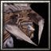

- Strange Dog:

Pandemic: Cooldown: 10/8/6/4/2=>12/10/8/6/4.



- Real Bro:

Bunnie: Ravage: Duration: 5=>3.



- Samurai:

Charged blade: Cooldown: 7=>4.

**BOSSES**

______________________________



- Mysterious hero: Mass polymorph effect is now refreshed only from heroes.

**BONUSES**

______________________________



- Curse: Banding: Effect changed: "At the end of the battle, changes uniques of each hero to random activated one."



- Curse: Reincarnation: Cooldown: 20=>30.

**OTHER**

______________________________

- Special: Burst of Energy: Mana: 25=>35.

- The positions of Uniques and Special have been swapped.

- Added an interface showing the current uniques and specials of the players.

- Added an interface showing the current number of resurrections in battle.

- Polymorph no longer works for sheep.

- Added new rotation: I'm legend.

- Added 2 new specials.

- Added a new event: One-time seller.

- Now, when manually loading progress, open rotations of items are also loaded (inactive after the start of the first battle).

**BUGS**

______________________________

- Fixed an issue that prevented the "Blacksmith craft" quest from working if the "Runestone Troy" artifact was in the inventory.

- Fixed an issue that could cause the "Pentagram" artifact to work incorrectly.

Boss Battle 1.4.4e (20.05.21)  
_________________________________________________________

[Discord server](https://discordapp.com/invite/KVfrcby)

[Database](https://docs.google.com/spreadsheets/d/1EKDcst62EP95DTYc0IeDh3wD8KcniLSq-fCki92ytxQ/edit#gid=1199919977)

[PayPal](https://www.paypal.me/bbwc3)

[Patreon](https://www.patreon.com/bbwc3)

 - Made with community feedback.

**ITEMS**

______________________________

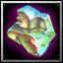

- Babbling pebble: Added a random bonus.



- Lollipop: Added a random bonus.



- Idol of Sin: Healing bonus: 75%=>150%.

**OTHER**

______________________________

- The shop interface has been improved.

- "Throw dice" command no longer works with any effects that interact with gold.

**BUGS**

______________________________

- Cute Bob is no longer affected by abilities and items that the minion could target.

- Other minor fixes.

Boss Battle 1.4.4d (19.05.21)  
_________________________________________________________

[Discord server](https://discordapp.com/invite/KVfrcby)

[Database](https://docs.google.com/spreadsheets/d/1EKDcst62EP95DTYc0IeDh3wD8KcniLSq-fCki92ytxQ/edit#gid=1199919977)

[PayPal](https://www.paypal.me/bbwc3)

[Patreon](https://www.patreon.com/bbwc3)

 - Made with community feedback.

**ITEMS**

______________________________

- The next artifacts have been removed from the map:

Afflicted blade

Apexis

Armored boots

Bleeding

Blood thickener

Casket of Yogg-Saron

Drums

Enchanted Contract

Essence of Shadow

Hearthstone

Heavy bag

Holiday gift

Hunter Badge

Magic branch

Neophyte mushrooms

Pandora's Box

Plate gauntlets

Runestone Peshi

Sunflower

Tarot Card: Devil

Unstable boominator

Voodoo-Amulet

Bloodstream

Chaos Earring

Idol of Pride

Magic eye

Night crab

Prismatic lens

Runestone Chandom

Time-Turner

Totem of Mutations

Werewolf blood

=>

- Glass of wine from Toussaint: Renamed to: "Idol of Hunger". Icon changed. Rarity: Legendary=>Rare. Vampirism: 40%=>60%. No longer part of the Blood Set.



- Orb of the Rolling Plains: Chain healing is now capped at 4 targets.

**HEROES**

______________________________

- Added new hero: Real Bro (Hybrid).

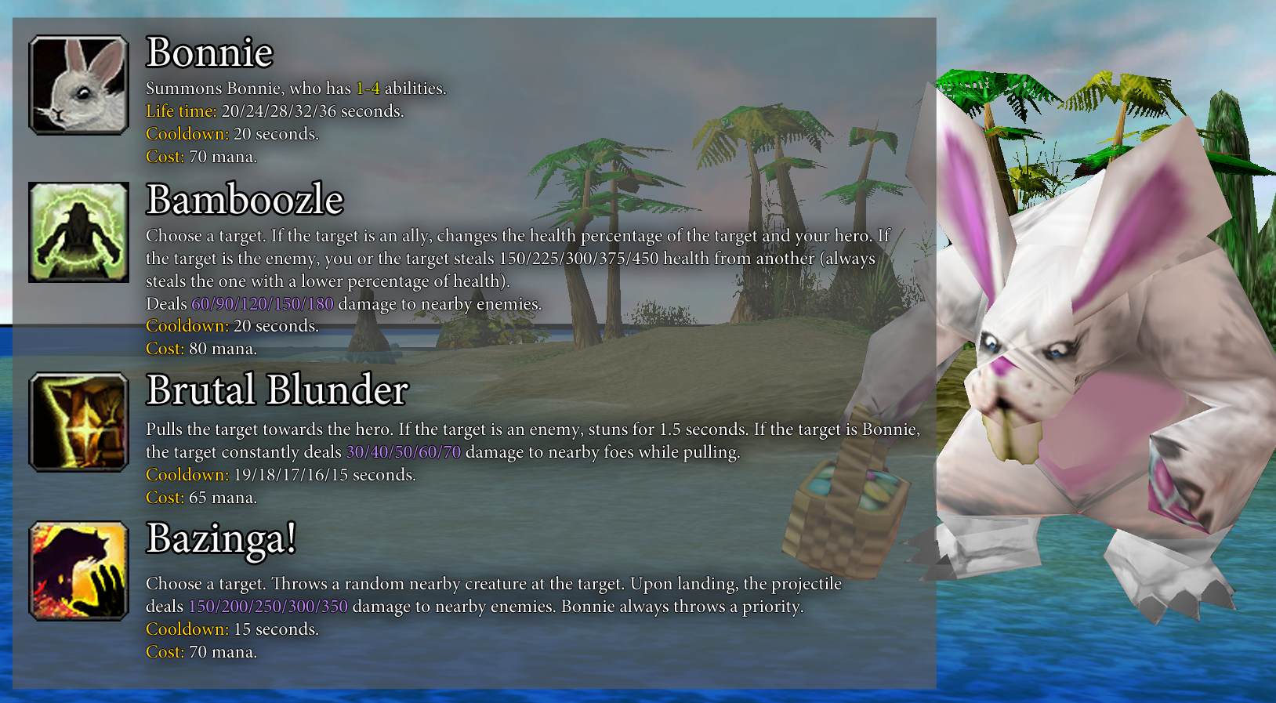



- Bard:

Bardic Inspiration: Chance: 6%/7%/8%/9%/10%=>4%/5%/6%/7%/8%.

**BONUSES**

______________________________



- Blessing: Luck: Luck bonus: 15=>10.



- Curse: Deficit: Effect changed: “Jule's prices increased by 10%.”

**OTHER**

______________________________

- The "Jule" store interface has been redesigned.

- Improved map optimization.

- Added 3 new specials.

- Voodoo explosion: Area of effect increased by 25%.

**BUGS**

______________________________

- Fixed an issue that sometimes caused "Throw dice" to work incorrectly.

- Fixed a visual issue that caused areas created by the "Manadragon" boss to not disappear after the boss dies.

- Fixed a visual issue that caused the damage description of the "Burn" ability to be incorrect if the ability was used by two or more heroes.

- Fixed an issue where the damage bonus from "Song of Joy" did not improve with level.

- Fixed an issue that caused the effect of the "Brass knuckles" artifact to spread to your minions if the item was in the "Ultimate Weapon".

- Fixed a bug due to which the mods that are triggered after defeating the first boss, worked incorrectly in endgame mode.

- Fixed an issue that prevented the spirit of the "Spirit figurine" artifact from disappearing when the item was removed.

- Fixed an issue that caused the use of abilities in polymorph to work incorrectly.

Boss Battle 1.4.4c (14.05.21)  
_________________________________________________________

[Discord server](https://discordapp.com/invite/KVfrcby)

[Database](https://docs.google.com/spreadsheets/d/1EKDcst62EP95DTYc0IeDh3wD8KcniLSq-fCki92ytxQ/edit#gid=1199919977)

[PayPal](https://www.paypal.me/bbwc3)

[Patreon](https://www.patreon.com/bbwc3)

 - Made with community feedback.

**ITEMS**

______________________________



- Crown of Night: Damage is no longer considered critical.

**BUGS**

______________________________

- Fixed an issue where any effects of changing an ability's uniques would cause the next triggers in the task list to stop working, causing the interface to appear incorrectly.

- Display positions of the first and third artifacts of rewards for the Red player now work correctly.

Boss Battle 1.4.4b (13.05.21)  
_________________________________________________________

[Discord server](https://discordapp.com/invite/KVfrcby)

[Database](https://docs.google.com/spreadsheets/d/1EKDcst62EP95DTYc0IeDh3wD8KcniLSq-fCki92ytxQ/edit#gid=1199919977)

[PayPal](https://www.paypal.me/bbwc3)

[Patreon](https://www.patreon.com/bbwc3)

 - Made with community feedback.

**ITEMS**

______________________________



- Mechatron Charizard: Cannot be split now.



- Love potion: Duration: 5=>8.

**BUGS**

______________________________

- Fixed an issue that could cause sets to work incorrectly.

- Fixed an issue where dying while berserked would teleport the hero to a safe area.

- Fixed an issue that sometimes caused the difficulty icon to display incorrectly.

- Fixed an issue where the "Play Note" ability would not work with uniques spell power.

- Fixed a visual issue that could cause spell power to appear behind the bar.

Boss Battle 1.4.4a (12.05.21)  
_________________________________________________________

[Discord server](https://discordapp.com/invite/KVfrcby)

[Database](https://docs.google.com/spreadsheets/d/1EKDcst62EP95DTYc0IeDh3wD8KcniLSq-fCki92ytxQ/edit#gid=1199919977)

[PayPal](https://www.paypal.me/bbwc3)

[Patreon](https://www.patreon.com/bbwc3)

 - Made with community feedback.

**ITEMS**

______________________________



- Orb of Volcano: Now volcano lasts 2 times longer, but creates rocks 2 times less often.

**HEROES**

______________________________



- Shoggoth:

Void Blast: Now again increases damage dealt per entropy. Bonus Damage: 3/6/9/12/15.

Ruin: Cooldown: 30=>22.



- Cool Wicerd:

Hot Elbows: Damage: 6/9/12/15/18=>20/24/28/32/36.

**OTHER**

______________________________

- Book of Oblivion no longer removes special abilities.

**BUGS**

______________________________

- The new "Magic transformer" store now appears when using the "-load" command.

- Fixed an issue that caused the "Ice Dragon" boss to take less ballista damage than he should have.

- Fixed an issue that caused the "Modes" button to disappear when selecting the "Magic transformer" store.

- Special ability selection interface now properly turns off when you choose to select another hero.

Boss Battle 1.4.4 (11.05.21)  
_________________________________________________________

[Discord server](https://discordapp.com/invite/KVfrcby)

[Database](https://docs.google.com/spreadsheets/d/1EKDcst62EP95DTYc0IeDh3wD8KcniLSq-fCki92ytxQ/edit#gid=1199919977)

[PayPal](https://www.paypal.me/bbwc3)

[Patreon](https://www.patreon.com/bbwc3)

 - Made with community feedback.

**ITEMS**

______________________________

- Added new items:

|  | Fairy meat | Alchemy. Activation: Deals **200** damage to the enemy. If you have only artifacts from the "Alchemy" set, it also increases the random stat by 1. Cooldown: 20 seconds. Cost: 40 mana. |
| --- | --- | --- |
|  | Goat Dragon Claw | Weapon. When the hero attacks, with a **10%** chance, increases the spell power for uniques by 20% until the end of the battle. Stacks up to 10 times. |



- Cloud horn: Life time: 30=>25.

**HEROES**

______________________________

- Added new hero: Bard (Hybrid).

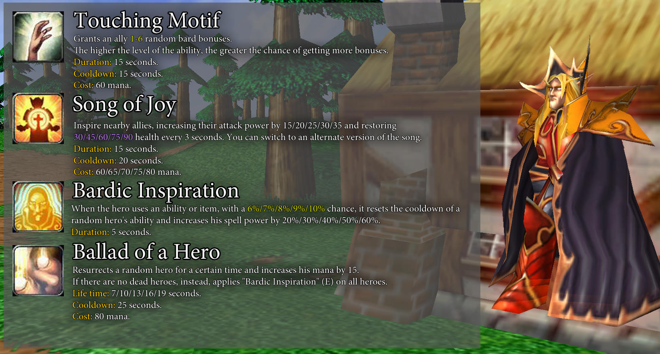

- Reaper's uniques "Sweeping blow" now deals 40% area damage instead of 25%. Range increased by 20%.



- Cool Wicerd:

Base ability slow changed from -25% to -35%. The slow in any ability now lasts 10 seconds.

Nah-ice!: Cooldown: 20=>10.

Ice-olation: Cooldown: 24/22/20/18/16=>15.

Hot Elbows: Slow bonus: -10%=>-15%.

Brain Freeze: Cooldown: 20=>10.



- Murloc-Medicaster:

Fish bite: The effect now lasts until the end of the battle, but can only be applied to 1 target. The hero no longer possesses passive vampirism. Cost: 60=>100.

Murlocpool: Effect changed: "Restores 120/170/220/270/320 health to the hero with the lowest percentage of health. Cooldown: 15 seconds. Cost: 50 mana."

Healing saliva: Duration: 10=>18.



- Berry Dealer:

Explosive Goods: No longer restores the target's health. Gold no longer depends on spell power. Cooldown: 25=>20.

Eagle Eye: Chance: 2%/3%/4%/5%/6%=>3%/5%/7%/9%/11%.

Harmless Offering: Bananas now taunt the target to attack themselves for 3 seconds. Bananas health reduced from 500 to 200.



- Gun Master:

Explosive grenade: Cooldown: 5=>8.

Shelling: Cooldown: 15=>20.



- Jester:

Juggling: Throwing Knife: Can now be used on a random target, but fires 2 projectiles.



- Ratman Shaman:

Polymorph: Rat: Cooldown: 40/36/32/28/24=>20. Now works in the selected area. Now works weaker on bosses. Duration: 5/7/9/11/13 seconds.

Plague Gift: The debuff is now generated every half second. Now deals damage every half second. Debuff duration: 10=>5.



- Infernal:

Infernal Plating: Now also restores 5% health when taking an Infernal Plate.



- Plague doctor:

Plague impact: Duration: 12=>15.

Transformation of prana: Health: 200/275/350/425/500=>250/325/400/475/550.



- Pyrolord:

Seal of the blast: Damage: 150/200/250/300/350=>250/300/350/400/450.



- Priestess of the Cat:

Cat Shrine: Duration: 20=>40.



- Dream Devouver:

Nightmares: Effect changed: "Makes the hero invisible. Duration: 10/15/20/25/30 seconds. Cooldown: 35 seconds. Cost: 60 mana."

Touch of horror: Effect changed: "Increases the received magic damage of the enemy by 20%/30%/40%/50%/60%. If the target dies under the effect, increases spell power by 1%/1.5%/2%/2.5%/3%. Duration: 20 seconds. Cooldown: 25 seconds. Cost: 60 mana."



- Keeper of the Great Tree:

Chaw of Chaws: Now active if there is another hero next to your hero.



- Mephistar:

Grant Wish: Cooldown: 26/24/22/20/18=>22/20/18/16/14.

Soul Contract: No longer uses health and mana. Number of additional charges: 0/0/1/1/2=>0/1/2/3/4.



- Money Bag:

Vore: Now deals single damage instead of percentage damage: 10%/20%/30%/40%/50%=>150/200/250/300/350.

Digest: Now steals the health and mana of the killed hero.

**BONUSES**

______________________________



- The "Reborn" blessing now deals 300 damage, instead of 500.

**OTHER**

______________________________

- Added new 3 specials.

- The special ability "Innervate" now restores 100 health and shield, instead of 125.

- Added a new store - Magic transformer. In it, you can buy any special ability for 100 gold. When buying, the old special is replaced with a new one. The store opens at the fifth level of progress.

- Hero's Soul deleted.

- "Throw dice" are back, but now they do not depend on luck and bonuses to gold, but does not reduce the chance of winning.

- Changed the system of inflicting damage: now the bonus damage is calculated first, and only then the armor is calculated.

BUGS

______________________________

- Fixed an issue where artifacts triggered by uniques would not work if the hero was under the effect of a soul swap.

- Fixed an issue that caused the "Fel Immolation" ability to continue working after being turned off.

- Fixed an issue that caused the "-debug" command to teleport heroes incorrectly.

- Fixed an issue where the "Repeller" artifact and the boss ability "Knight in strange armor" could cause the unit to not respond to commands.

- Fixed an issue that caused the "Steam generator" artifact to work incorrectly with copies of itself.

- The "Mechatron Charisard" artifact now works more correctly with other sets.

- The "Poison" artifact is now correctly triggered when reapplying the effect.

Boss Battle 1.4.3q (07.05.21)  
_________________________________________________________

[Discord server](https://discordapp.com/invite/KVfrcby)

[Database](https://docs.google.com/spreadsheets/d/1EKDcst62EP95DTYc0IeDh3wD8KcniLSq-fCki92ytxQ/edit#gid=1199919977)

[PayPal](https://www.paypal.me/bbwc3)

[Patreon](https://www.patreon.com/bbwc3)

 - Made with community feedback.

**BOSSES**

______________________________

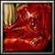

- Salamander: Now the boss does not move if polymorphed or stopped.

**BUGS**

______________________________

- Fixed an issue that caused artifacts that create items at the end of combat to work incorrectly with cursed items.

- Fixed an issue where stun effects might not end.

Boss Battle 1.4.3p (06.05.21)  
_________________________________________________________

[Discord server](https://discordapp.com/invite/KVfrcby)

[Database](https://docs.google.com/spreadsheets/d/1EKDcst62EP95DTYc0IeDh3wD8KcniLSq-fCki92ytxQ/edit#gid=1199919977)

[PayPal](https://www.paypal.me/bbwc3)

[Patreon](https://www.patreon.com/bbwc3)

 - Made with community feedback.

**ITEMS**

______________________________

- Added new items:

|  | Draupnir | Ring. At the end of the fight, it gives a random ring. Any rings you pick up receive a random bonus. Random bonus. |
| --- | --- | --- |
|  | Ring of Addiction | Ring. Alchemy. When the hero uses uniques, there is a 50% chance to use a random potion. |
|  | Dice of Chaos | Activation: Roll the dice of chaos! Who knows what will happen? Cooldown: 10 seconds. |
|  | Salad of Wonders | Nature. Activation: Restores 1-400 health to the hero. If the inventory is full, Corrupted. Cooldown: 15 seconds. Cooldown: 25 mana. |
|  | Runestone Info | Rune. When your minion is summoned, it increases its attack power and health by 40%. Reduces the movement speed of your minions by 20%. |



- Babbling pebble: Effect changed: "Increases damage dealt by 40% if mana is less than 25%."



- Copy-Cat: Now works in combat.



- Chrysolite of Control: Cost: 150=>75. The effect now lasts 60 seconds and does not stack.



- Orb of Cenarius: No longer part of the "Nature" set.



- Orb of the Enchanted Woods: No longer part of the "Moon" set.



- Inferno: Now summons Infernals under the yellow player's control, but their life time has been reduced to 15 seconds. Now summons an Infernal for each fifth creature.



- Magic meat: Effect changed: "At the start of the fight, increases the charges of your potions by 3, but curses them. Random bonus"



- Newt's Magic Casket: Chelpius has been added to the list of exotic creatures. Life time: 25=>30. Cooldown: 60=>45. Cost: 100=>75.



- Glass of wine from Toussaint: Effect changed: "Any damage of the hero has 40% vampirism, but the hero loses 40 health per second."

**HEROES**

______________________________

- Added new hero: Abyssal Infernal (Defender).

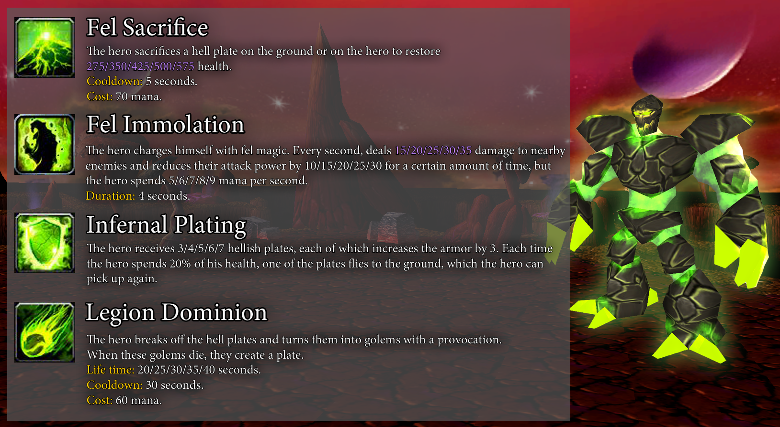



- Shoggoth:

Void Blast: Damage: 120/160/200/240/280=>170/205/240/275/310.

Ruin: Now summons more larvaes.



- Gambler:

Double Down: Now summons an illusion with the hero's current health and mana.

Fixed Odds: Luck: 100/125/150/175/200=>100.



- Metal Mage:

Metallica: No longer has a life time, but you can no longer summon more than one golem. Cost: 60/65/70/75/80=>75.



- Gun Master:

Shelling: Damage: 80/95/110/125/140=>60/76/88/100/112.

**BOSSES**

______________________________



- The "Mechanic" boss has returned to the arena.



- Pit Lord: The boss's Mana Burn ability no longer depends on spell power.

**OTHER**

______________________________

- "Throw dice" deleted.

- The huckster has a new unusual product - Hero's Soul.

- Berserker effect now makes heroes allied to the boss.

- The effects of polymorph and hex are now a debuff and can be enhanced by the effects of changing the duration.

**BUGS**

______________________________

- Fixed an issue that prevented the Phoenix Egg artifact from working when changing souls.

- "Power up!" mode now works correctly in the fight with the first boss.

- Fixed an issue that prevented the "Ring of Light" artifact from working.

- The "Battle of power" quest is no longer completed if the hero is dead.

- Fixed an issue that prevented the "Orb of Manaburn" artifact from granting a spell power bonus.

- Fixed an issue where the "Mode - Shotgun" ability did not increase the number of projectiles per level.

- Fixed an issue where the enhanced version of the "Burning gaze" ability would not work with the "Witcher medallion" artifact.

- Fixed an issue where the "Berserker" effect might not end when fighting the "Berserker" boss.

- Fixed an issue that caused the "Orb of the Rolling Plains" artifact to sometimes not work correctly with hero resurrection effects.

- Fixed an issue that caused the "Katana" artifact to work for your minions.

- Fixed an issue that prevented silenced heroes from using abilities after a polymorph.

Boss Battle 1.4.3o (29.04.21)  
_________________________________________________________

[Discord server](https://discordapp.com/invite/KVfrcby)

[Database](https://docs.google.com/spreadsheets/d/1EKDcst62EP95DTYc0IeDh3wD8KcniLSq-fCki92ytxQ/edit#gid=1199919977)

[PayPal](https://www.paypal.me/bbwc3)

[Patreon](https://www.patreon.com/bbwc3)

 - Made with community feedback.

**ITEMS**

______________________________



- Midas Ring: Now works in combat.



- Tarot Card: Wealth: Now only works on artifacts.



- Tarot Card: Wheel of Fortune: Now only works on artifacts.



- Totem of Gaze Burning: Life time: 30=>20.



- Cane of Khnum: Effect changed: "Activation: Transforms up to 30 of your sheeps into random minions. Life time: 15 seconds. Cooldown: 25 seconds. Cost: 80 mana."



- Glass of wine from Toussaint: Life time: 90=>45.

**HEROES**

______________________________



- Gun Master:

Mode - Shotgun: The spread of shells has been slightly reduced.



- Shoggoth:

Void Blast: No longer deals additional entropy damage.

Writhing Mass: Now grants entropy with a 20% chance, instead of 100%.

**BONUSES**

______________________________



- Added a new bonus:

[BLESSING] Rune-making. At the beginning of the battle, create 6 arena runes.

**OTHER**

______________________________

- Now when you select a hero, the camera is automatically set to "-cam 3" mode.

**BUGS**

______________________________

- Fixed an issue that prevented the "Playful spirit" artifact from working.

- The "Regnum Irae" ability now works correctly with the "Crystal" set.

Boss Battle 1.4.3n (28.04.21)  
_________________________________________________________

[Discord server](https://discordapp.com/invite/KVfrcby)

[Database](https://docs.google.com/spreadsheets/d/1EKDcst62EP95DTYc0IeDh3wD8KcniLSq-fCki92ytxQ/edit#gid=1199919977)

[PayPal](https://www.paypal.me/bbwc3)

[Patreon](https://www.patreon.com/bbwc3)

 - Made with community feedback.

**ITEMS**

______________________________

- Added a new type of artifacts - Cursed. Cursed artifacts disappear at the end of the battle.

- Added new items:

|  | Ring of Identity | Blood. Rune. Mech. Moon. Nature. Alchemy. Ring. Crystal. Cannot be splitted. |
| --- | --- | --- |
|  | Elune's Ring | Moon. Ring. Every seventh hit of the hero triggers the "Moon" set bonus. Random bonus. |
|  | Orb of Shadow | Increases attack power by 15%. When the hero attacks a minion, with a probability of 8%, the target comes under your control. Life time: 30 seconds. |
|  | Magic box | Activation: Gives an artifact. It becomes cursed. Only works in combat. Coldown: 20 seconds. Cost: 40 mana. |
|  | Cursed Amulet | Cursed. Increases stats by 30. |
|  | Blooming weed | Nature. At least 1 artifact reward will be from the nature set. Random bonus. Random bonus. |



- D20: Cooldown: 30=>10. Now only works in combat.



- Life incubator: Added 2 random bonuses.



- Orb of the Rolling Plains: Chain healing range increased by 60%.



- Orb of Pious Magi: Spell power bonus: 10%=>15%. Health regeneration bonus: 5=>8.



- Orb of Tirion Fordring: Effect changed: "Increases health regeneration by 12. When the hero attacks, with a 15% chance, the chain reaction deals 100 damage to the target and nearby enemies and provokes them to attack the hero. Duration: 4 seconds."



- Crystal of Power: Renamed to: "Soul Crystal". Effect changed: "When you kill an enemy, it absorbs their soul. Activation: Deals 200 damage to the enemy. Destroys all souls and deals an additional 200 damage per soul. Souls disappear at the end of the fight. Cooldown: 30 seconds. Cost: 75 mana."



- Staff of Purity: Effect changed: "At the beginning of the battle, fills the inventory with purified matter." Purified matter: Effect changed: "Cursed. Increases stats by 4."



- Soul of Determination: Can now be used multiple times per battle. Now works correctly if received in battle.

**HEROES**

______________________________

- Added a new hero: Gun Master (Killer).

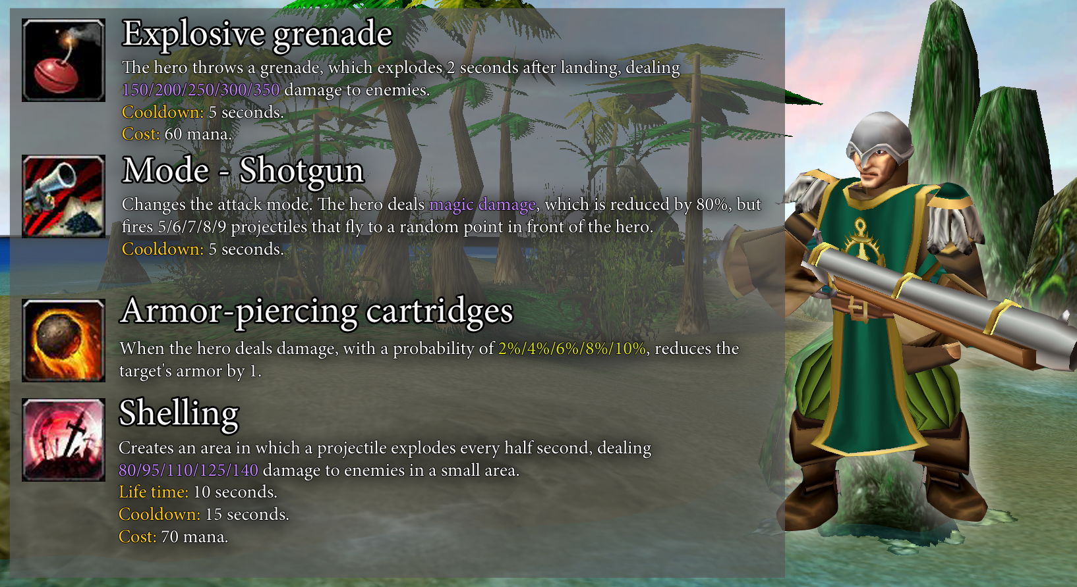

- The hero "Shoggoth" has been reworked:

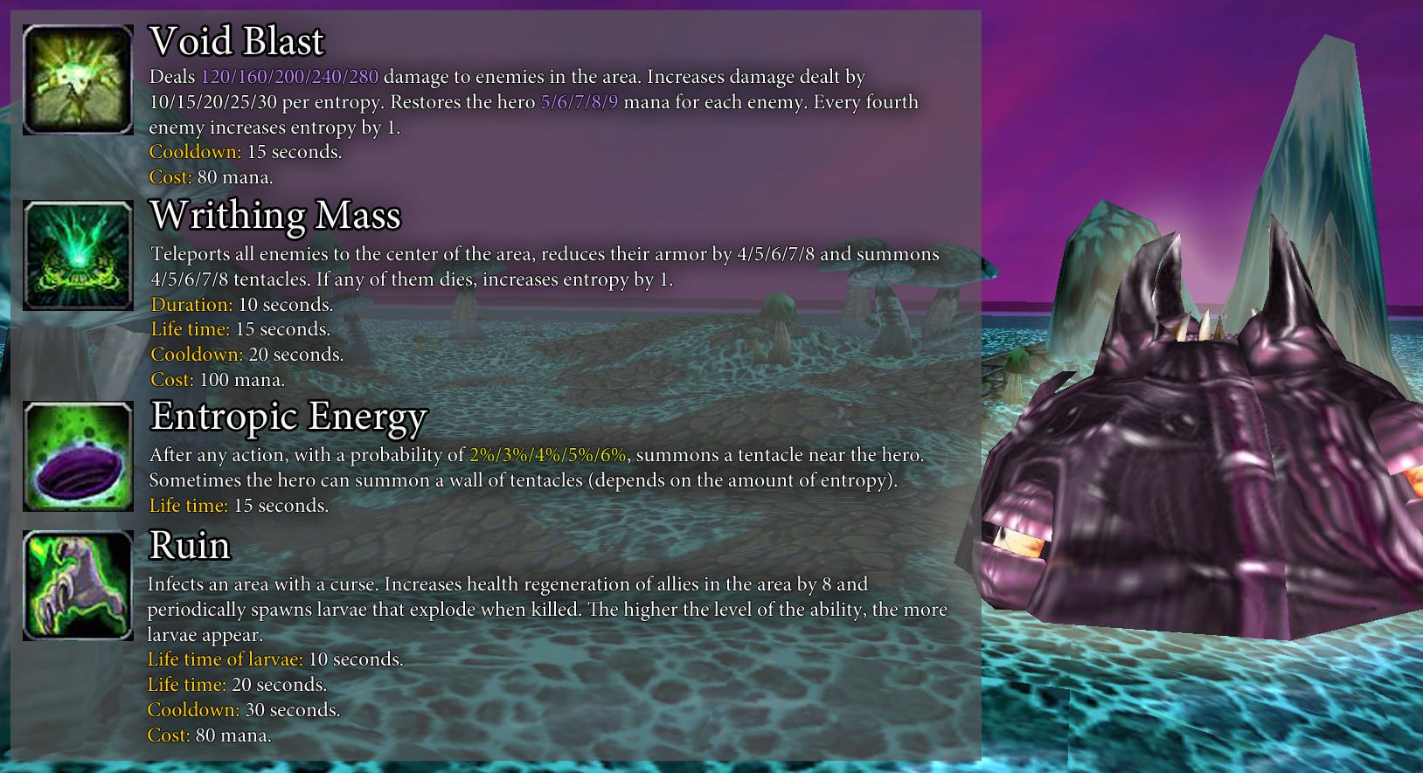



- Wanderer:

Veritus Mortuus: Cost: 65=>45.

Impius Imperium: Cost: 40=>60 (mana).



- Strange Dog:

Ravenous Bite: Effect changed: "Deals 100/150/200/250/300 damage to the target and restores the same health to the hero. The lower the target's health, the more damage it deals (up to +300%). If the target dies, it resets the cooldown of the ability. Cooldown: 12 seconds. Cost: 35/40/45/50/55 mana."

Pandemic: Effect changed: "Deals damage equal to 8% of the hero's maximum health to all enemies in a large area. If the target is affected by the "Blight" effect, restores the hero's health equal to the damage done. Cooldown: 10/8/6/4/2 seconds. Cost: 80 health."



- Apex Predator:

Aqua Jet: Damage Reduction Bonus: 6%/9%/12%/15%/18%=>9%/13%/17%/21%/25%.

Origin Pulse: Attack Power Bonus: 8%/12%/16%/20%/24%=>25%/35%/45%/55%/65%. Cooldown: 28/26/24/22/20=>30.



- Dryad:

Call of nature: Now you cannot summon more than 4 minions. It is no longer possible to summon a copy of an already summoned minion.



- Troll Mage:

Arcane strike: Damage: 100/150/200/250/300=>80/120/160/200/240.

**BOSSES**

______________________________



- Angry bob: 80%: Jump: Cooldown: 20=>15.

**BONUSES**

______________________________



- Added a new bonus:

[BLESSING] Foresight. You know which boss you will fight.

**OTHER**

______________________________

- Guilds have been temporarily removed.

- Added a new rotation: Orbomination.

- The interface of the icons with tips for the current modes has been changed.

- Added new skins: Troll Mage (lv.14), Wanderer (lv. 20).

- The random bonus system has been updated. Old effects have been balanced and new ones have been added.

- The "Change artifacts" button now disappears if a reward artifact is picked up, rather than after all reward artifacts have disappeared.

**BUGS**

______________________________

- Fixed an issue that caused the "Mimic potion" artifact to work incorrectly.

- Fixed an issue that prevented Regnum Irae from dealing damage.

- The quest "Greed is Gold" can no longer be completed if the hero is dead.

- Fixed a bug that caused some heroes to have 1 more intelligence than they should.

Boss Battle 1.4.3m (20.04.21)  
_________________________________________________________

[Discord server](https://discordapp.com/invite/KVfrcby)

[Database](https://docs.google.com/spreadsheets/d/1EKDcst62EP95DTYc0IeDh3wD8KcniLSq-fCki92ytxQ/edit#gid=1199919977)

[PayPal](https://www.paypal.me/bbwc3)

[Patreon](https://www.patreon.com/bbwc3)

 - Made with community feedback.

**HEROES**

______________________________



- Living Altar:

Ascendance: Now brings the hero out of alternate form when improving other abilities.

**OTHER**

______________________________

- The hero selection interface has been slightly changed.

**BUGS**

______________________________

- Fixed an issue where artifacts with the "Forge" mechanic, which should give the player more than one artifact, always gave 1.

Boss Battle 1.4.3L (19.04.21)  
_________________________________________________________

[Discord server](https://discordapp.com/invite/KVfrcby)

[Database](https://docs.google.com/spreadsheets/d/1EKDcst62EP95DTYc0IeDh3wD8KcniLSq-fCki92ytxQ/edit#gid=1199919977)

[PayPal](https://www.paypal.me/bbwc3)

[Patreon](https://www.patreon.com/bbwc3)

 - Made with community feedback.

**ITEMS**

______________________________

- Added new items:

|  | Chameleon Eye | Ring. After the hero has used uniques, turns it into a random activated uniques. Random bonus. |
| --- | --- | --- |
|  | Orb of Light | Increases health regeneration by 5. If there is another orb in the inventory, they merge. Activation: Restores **300** health. Cooldown: 30 seconds. Cost: 50 mana. |
|  | Fortune-telling ball | Activation: Forges an item. The item is guaranteed to be one of your reward artifacts. Coldown: 60 seconds. |

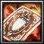

- Tarot Card: Courage: Effect changed: "Activation: Corrupted. Increases stats by 3."



- Runestone Spir: Effect changed: "At the end of battle, forges a rune."



- Vine Trap: Cost: 50=>20.

=>

- Golden Lamp: Icon changed.



- Cosmic Reed: Damage: 25%=>35%.



- Gnomish Soulspin: Healing: 30%=>40%.



- Blood of the Ancient: Duration: 15=>25.



- Light of life: Cost: 300=>200.



- Icethorn: Shield bonus: 20%=>30%.



- Archivist's Staff: Rarity: Legendary=>Rare. Mana bonus: 120=>100. Spell power bonus: 12%=>10%.



- Star in a bottle: Rarity: Legendary=>Rare.



- Midas Ring: Rarity: Legendary=>Rare.

**HEROES**

______________________________

- Added a new hero: Wanderer (Encourager).

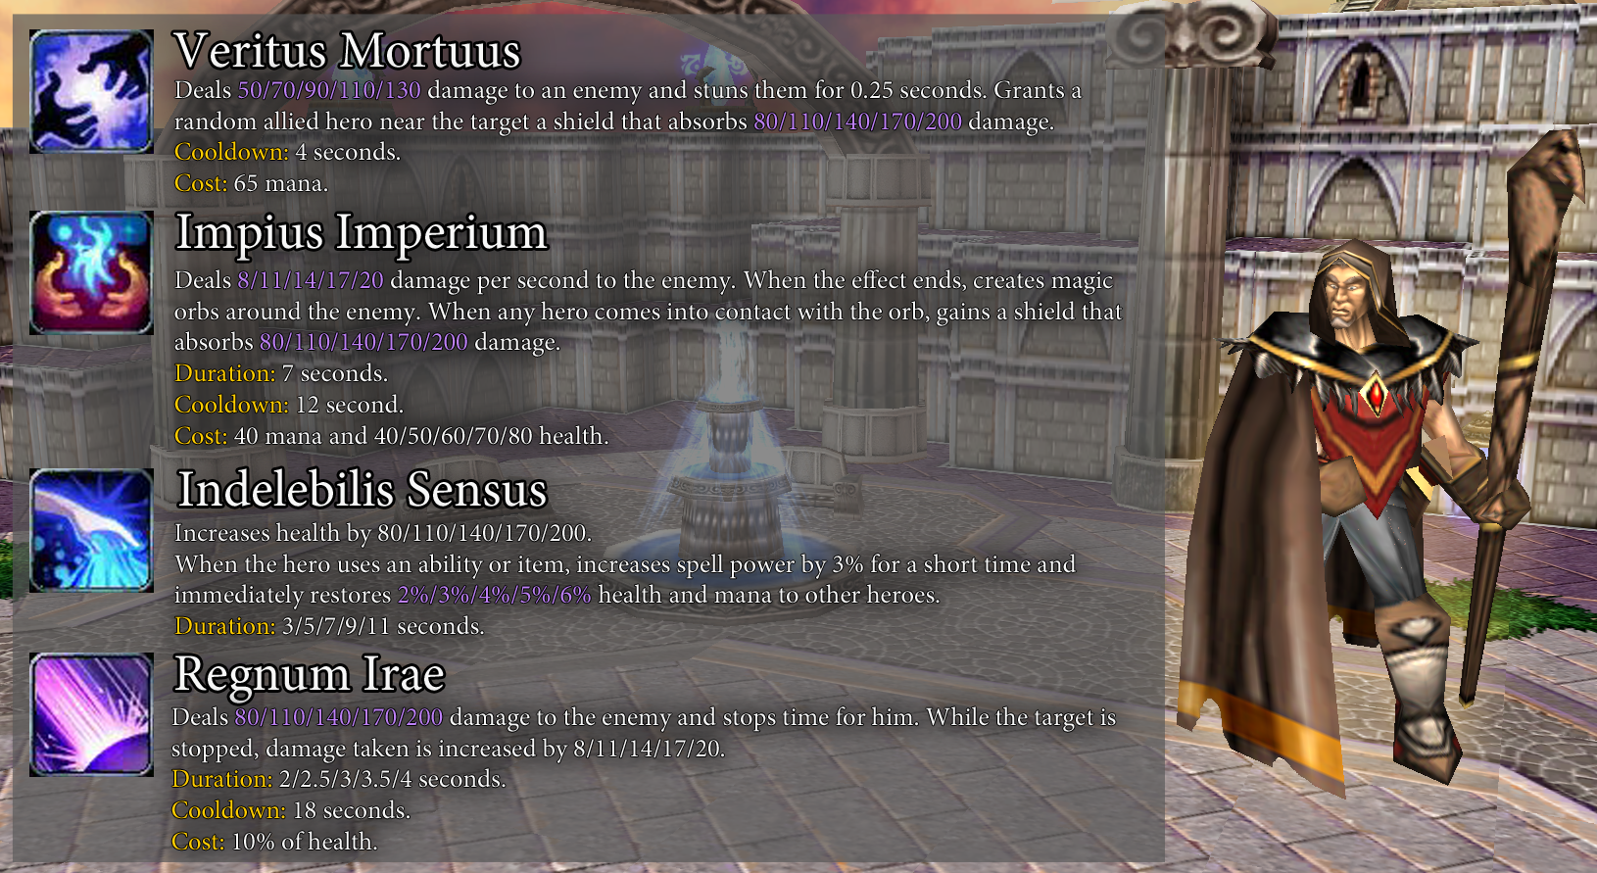



- Monk:

The hero's uniques have been enhanced:

Crane Style: Health Regeneration: 3=>5.

Mantis Style: Mana Regeneration: 2=>3.

Tiger Style: Attack Speed: 20%=>25%.



- Mephistar:

Soul Contract: Icon size reduced by 35%.

**BOSSES**

______________________________



- Paladin: Temporarily removed from the map.

**BUGS**

______________________________

- "Royal Chameleon" can no longer transform into "Warrior's Belt" and "Magic meat".

- Fixed a visual issue due to which the display of the completed guild quest did not work correctly.

Boss Battle 1.4.3k (17.04.21)  
_________________________________________________________

[Discord server](https://discordapp.com/invite/KVfrcby)

[Database](https://docs.google.com/spreadsheets/d/1EKDcst62EP95DTYc0IeDh3wD8KcniLSq-fCki92ytxQ/edit#gid=1199919977)

[PayPal](https://www.paypal.me/bbwc3)

[Patreon](https://www.patreon.com/bbwc3)

 - Made with community feedback.

**ITEMS**

______________________________

- Added new items:

|  | Royal Chameleon | Activation: Transforms into a random activated artifact. The new artifact has this effect. Only works in battle. |
| --- | --- | --- |
|  | Nehalena's Eye | Activation: Corrupted. Choose a hero. Forge this hero's artifact reward from the last pick. |
|  | Tarot Card: Doppelganger | Activation: Corrupted. Copies another hero's agility. |
|  | Pact of Fire | Activation: Corrupted. Increases stats by 1 and spell power for uniques by 25%. |



- Rubedo's Belt: The artifact has returned to the map. Effect changed: "With a probability of 50%, the first corrupted artifact in battle is not destroyed. Random bonus."



- Magic Absorber: Spell damage bonus: 0.5%=>0.3%. Added a random bonus.

**HEROES**

______________________________



- Keeper of the Great Tree:

Chaw of Chaws: Attack and movement speed bonus: 10%/15%/20%/25%/30%=>-10%/-5%/0%/5%/10%.



- Priestess of the Cat:

Tabby, Tabby Crusher: Cooldown: 25=>20. The hero's attack power bonus no longer stacks.

**BOSSES**

______________________________



- Mechanic: Temporarily removed from the map.

**OTHER**

______________________________

- Hotkeys have been added for some actions:

ESC - close the quest selection window.

ESC - hide/unhide the mod window.

Tab - hide/unhide guild quest progress window.

- The "Copy-Cat" artifact and parts of the knight set can no longer be purchased in the guild.

Boss Battle 1.4.3j (15.04.21)  
_________________________________________________________

[Discord server](https://discordapp.com/invite/KVfrcby)

[Database](https://docs.google.com/spreadsheets/d/1EKDcst62EP95DTYc0IeDh3wD8KcniLSq-fCki92ytxQ/edit#gid=1199919977)

[PayPal](https://www.paypal.me/bbwc3)

[Patreon](https://www.patreon.com/bbwc3)

 - Made with community feedback.

**ITEMS**

______________________________



- Amber: Rarity: Rare=>Common.



- Thundering citrine: Damage: 5=>10.



- Magician's Boots: Cost: 50=>35.

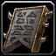

- Runestone Mos: Chance: 15%=>20%.

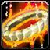

- Farelo the Fiery: Cooldown reduction: 1=>0.75.

**HEROES**

______________________________



- Priestess of the Cat:

Meowssault: Cooldown: 40=>20. Stray cats base damage increased from 12 to 15.

Tabby, Tabby Crusher: Attack power bonus for stray cats: 20%/30%/40%/50%/60%=>20%/35%/50%/65%/80%. Cooldown: 20=>25. No longer increases attack power if your current attack power is greater than 10,000.

**BOSSES**

______________________________



- Sea Turtle: The boss is back on the map.

**OTHER**

______________________________

- Command "-delpl" renamed to "-kick"

**BUGS**

______________________________

- Fixed an issue where the waves of the "Crab" boss could lead to an abrupt end of the game.

Boss Battle 1.4.3i (14.04.21)  
_________________________________________________________

[Discord server](https://discordapp.com/invite/KVfrcby)

[Database](https://docs.google.com/spreadsheets/d/1EKDcst62EP95DTYc0IeDh3wD8KcniLSq-fCki92ytxQ/edit#gid=1199919977)

[PayPal](https://www.paypal.me/bbwc3)

[Patreon](https://www.patreon.com/bbwc3)

 - Made with community feedback.

**ITEMS**

______________________________

- Added new items:

|  | D20 | Activation: Transforms all other artifacts in the inventory to others of the same rarity. Cooldown: 30 seconds. |
| --- | --- | --- |
|  | Orb of Nature | Increases mana by 75. If there is another orb in the inventory, they merge. Activation: Restores **400** health over time. Duration: 10 seconds. Cooldown: 30 seconds. Cost: 50 mana. |
|  | Stim Injector | Blood. Mech. Activation: Increases attack and movement speed by 20% for each mech. Also increases health regeneration by 20. Duration: 20 seconds. Cooldown: 60 seconds. Cost: 150 health. |
|  | Magic Dispenser | Increases spell power by 0.5% for each point of your hero's agility. |
|  | Magic Absorber | Increases spell power by 0.5% for each point of your hero's intelligence. |



- Bandage: Added 2 random bonuses.



- Star in a bottle: Added a random bonus. No longer part of the "Moon" set.



- Twilight lamp: Now part of the "Moon" set.



- Idol of Anger: Renamed to "Idol of Wrath".



- Rubedo's Belt: The artifact has been temporarily removed from the map. This artifact will return in future updates.



- Prophet mask: Cooldown: 10=>3.

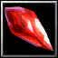

- Ruby diamond: Cooldown: 45=>30.



- Sundial: Rarity: Rare=>Common.



- Visarius the Follower: Healing: 10%=>20%.



- Falka: Added 1 random bonus.



- Farik the Tricky: Added 1 random bonus.



- Golden statuette: Added 1 random bonus.

**HEROES**

______________________________

- Added a new hero: Priestess of the Cat (Killer).

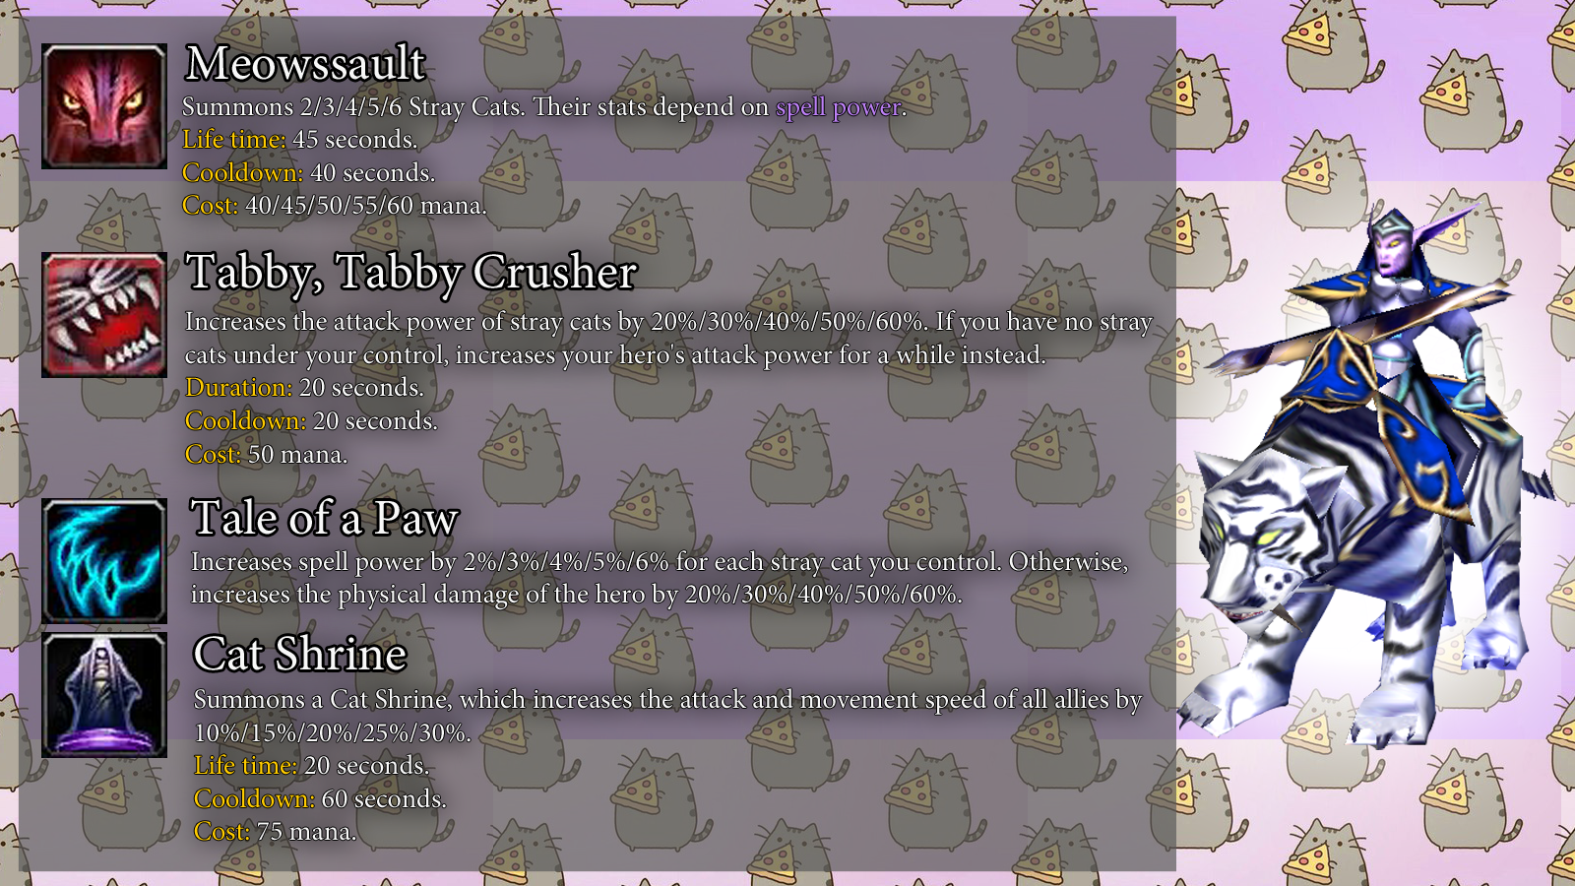



- Chronomancer:

Paradox: Damage: 15/20/25/30/35=>10/15/20/25/30.



- Keeper of the Great Tree:

Starsight: Cooldown: 18/17/16/15/14=>16/15/14/13/12.



- Crazy Shooter:

Offhand shooting: Effect changed: "If the hero does not take damage within 4 seconds, increases attack speed by 15%/20%/25%/30%/35% and attack power by 15/20/25/30/35."



- Ratman Shaman:

Conjure Cheddar Cheese: Now only works with hero attacks. Rat summoning chance: 15%=>20%.

**BOSSES**

______________________________



- Paladin: No longer restores health from healing enemies. 50%: Damage: 80=>150.



- The "Sea turtle" boss has been temporarily removed from the map.

**BONUSES**

______________________________



- Added a new curse: Mystery. One artifact reward for each player is always classified.

**OTHER**

______________________________

- Now the range of attacks of heroes on the target is reduced out of combat.

- Added a new random event: Bugger.

- The size, attack range, and attack speed of the tentacle caused by any effects have been increased.

- "Provocation" ability no longer works on invulnerable targets.

- Changed interface for guild quest progress.

- The "-quest" command has been removed.

- The "-zoom X" and "-cam X" commands have been changed. Now, instead of the distance value, you need to write a number from 1 to 5, which will automatically correct the camera's distance.

- "Rune of Mana" that appears in additional arenas now restores 75 mana, instead of 125.

**BUGS**

______________________________

- Fixed a bug due to which it was not possible to select more than one "Lord of Chaos" hero in the game.

- Fixed an issue that prevented the "Wool Spindler" and "Dream Catcher" artifacts from working with the minions summoned by the "Mysterious Hero" boss.

- Fixed an issue that could cause the "Insatiable flame" artifact to work incorrectly.

- Fixed an issue that caused the "Chrono acceleration" and "Paradox" abilities to work incorrectly.

- Fixed a bug due to which some skins did not have glow effects and shadows.

- Fixed a bug that caused heroes in berserk state to become controlled by the red player upon death.

- Fixed an issue where the "Sheep Mantle" artifact could silence heroes indefinitely.

- Fixed an issue where damaging the cheese created by "Conjure Cheddar Cheese" while changing souls would not heal the hero.

Boss Battle 1.4.3h (09.04.21)  
_________________________________________________________

[Discord server](https://discordapp.com/invite/KVfrcby)

[Database](https://docs.google.com/spreadsheets/d/1EKDcst62EP95DTYc0IeDh3wD8KcniLSq-fCki92ytxQ/edit#gid=1199919977)

[PayPal](https://www.paypal.me/bbwc3)

[Patreon](https://www.patreon.com/bbwc3)

 - Made with community feedback.

**ITEMS**

______________________________

- Added a new quests:

|  | Greed is Gold | Quest: Earn 7500 gold per game. Reward: Hand of Midas. |
| --- | --- | --- |
|  | Scholar's Gambit | Quest: Buy 30 books. Reward: Scientist library card. |

**OTHER**

______________________________

- Added new rotations: "Sheep is good", "Corrupted World".

**BUGS**

______________________________

- Fixed a bug due to which it was possible to buy 2 of the same quest.

- Fixed an issue that caused the "Tarot Card: Courage" artifact to work incorrectly.

- Fixed an issue that caused the "Mark of blood" ability to work incorrectly.

Boss Battle 1.4.3f (07.04.21)  
_________________________________________________________

[Discord server](https://discordapp.com/invite/KVfrcby)

[Database](https://docs.google.com/spreadsheets/d/1EKDcst62EP95DTYc0IeDh3wD8KcniLSq-fCki92ytxQ/edit#gid=1199919977)

[PayPal](https://www.paypal.me/bbwc3)

[Patreon](https://www.patreon.com/bbwc3)

 - Made with community feedback.

**ITEMS**

______________________________

- Added new item:

|  | Orb of Earth | Increases health by 200. When the hero attacks, reduces the attack power of the target by 15%. If there is another orb in the inventory, they merge. Duration: 4 seconds. |
| --- | --- | --- |
|  | Camouflage paint | Activation: You put on the perfect camouflage. Camouflage has a maximum movement speed and 50% of your maximum health. Cooldown: 60 seconds. |
|  | Wool Spindler | When any sheep dies, you get 3 gold. Random bonus. Random bonus. |
|  | Wool Armor | Redirects any damage you take to your sheeps. Random bonus. Random bonus. |



- Added new quest:

Blacksmith craft. Quest: Refuse artifact-rewards 4 times. Reward: Pandora's bag.



- Totem of Gaze Burning: Totems now activate every 5 seconds instead of 3.



- Symbol of Maiev: Range: 600=>900.



- Orb of Khadgar: Cooldown: 60=>90.



- Tarot Card: Time: Now also restores all heroes' mana.

**HEROES**

______________________________

- Added a new hero: Keeper of the Great Tree (Encourager).

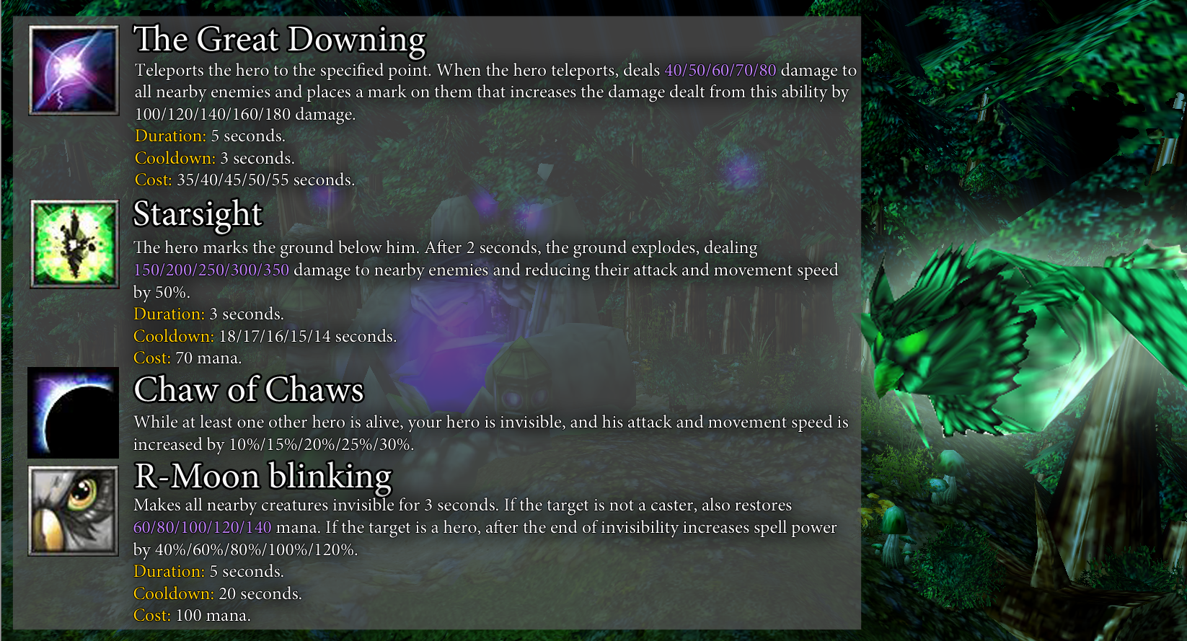



- Jester:

Magic Trick: Cooldown: 3=>1.5. Cost: 25=>20.



- Divine Maiden:

Divine Intervention: Can no longer be used on invisible targets.

**BOSSES**

______________________________



- Duelist: Now increases champion pick range every second while standing still.

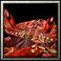

- Crab: Now takes 20% less damage from magic. Boss activation abilities changed from 75%/50%/25% to 90%/65%/40%.



- Ice Dragon: At 50%: Effect no longer deals damage, but reduces attack and movement speed by 25% for 15 seconds.

**OTHER**

______________________________

- Added a new random event: Dispenser.

- "Fast start" and "Apocalypse of Random" modifiers no longer reduce experience gain.

- Apocalypse of Random: Effect changed: "All heroes get into chaos. At the end of the battle, all artifacts turn into random ones of the same rarity."

**BUGS**

______________________________

- Conjure Cheddar Cheese now works correctly with the caster's healing modifiers.

- Fixed a bug due to which skins sometimes did not work correctly when using the "On a new one!" mode.

- Fixed an issue that prevented the "Demonic Warglaive" artifact from being consumed by the "Ultimate Weapon" artifact if the "Crystal Barrier" artifact was in it.

- Fixed an issue that prevented the "Steam generator" and "Superbot-5000" artifacts from working with the "Keen mind" uniques.

- The bonus damage of the "Manadragon" boss now works correctly with damage modifiers.

- Fixed an issue that prevented the quest selection bar from disappearing when you select a different hero.

- Fixed a bug due to which the boss "Blade master" could stop doing anything if the target, which the boss was jumping into, died before the end of the jump.

- Fixed an issue that prevented the "Tarot Card: Courage" artifact from working with the "Immortal story" quest.

Boss Battle 1.4.3c (02.04.21)  
_________________________________________________________

[Our discord server](https://discordapp.com/invite/KVfrcby)

[PayPal](https://www.paypal.me/bbwc3)

[Patreon](https://www.patreon.com/bbwc3)

 - Made with community feedback.

**ITEMS**

______________________________



- Earth Potion: Healing: 200=>225.

**HEROES**

______________________________



- Ratman Shaman:

Ratstoration: Healing: 100/125/150/175/200=>140/180/220/260/300. Now always summons a rat.

**BUGS**

______________________________

- Fixed an issue that caused some stat boosting abilities to not properly remove bonuses.

- Quests "Hunger for knowledge" and "Power search" are available for purchase again.

- Fixed an issue that prevented the "Magic meat" artifact from working with the "Immortal story" quest.

Boss Battle 1.4.3b (01.04.21)  
_________________________________________________________

[Our discord server](https://discordapp.com/invite/KVfrcby)

[PayPal](https://www.paypal.me/bbwc3)

[Patreon](https://www.patreon.com/bbwc3)

 - Made with community feedback.

**ITEMS**

______________________________

- Added new items:

|  | Mimic Orb | Activation: Corrupted. Forges an orb twice. |
| --- | --- | --- |
|  | Orb of Arcane | Increases spell power by 10%. When using an ability or item, there is a 15% chance of spending 50% less mana. If there is another orb in the inventory, they merge. |
|  | Orb of Frost | Increases armor by 3. When the hero attacks, slows down the target, reducing their attack and movement speed by 15%. If there is another orb in the inventory, they merge. Duration: 4 seconds. |
|  | Orb of Fire | Increases attack speed by 10%. When the hero attacks, **20%** of the damage is dealt to all nearby enemies. If there is another orb in the inventory, they merge. |



- Added new quest: Immortal story: Quest: Gain 25 intelligence with artifacts. Reward: Kobzar.



- Void Orb: Renamed to "Egg of the Void".



- Farik the Tricky: Effect changed: "Reduces the cooldown of uniques by 50%."

**HEROES**

______________________________

- Added new hero: Jester (Killer).

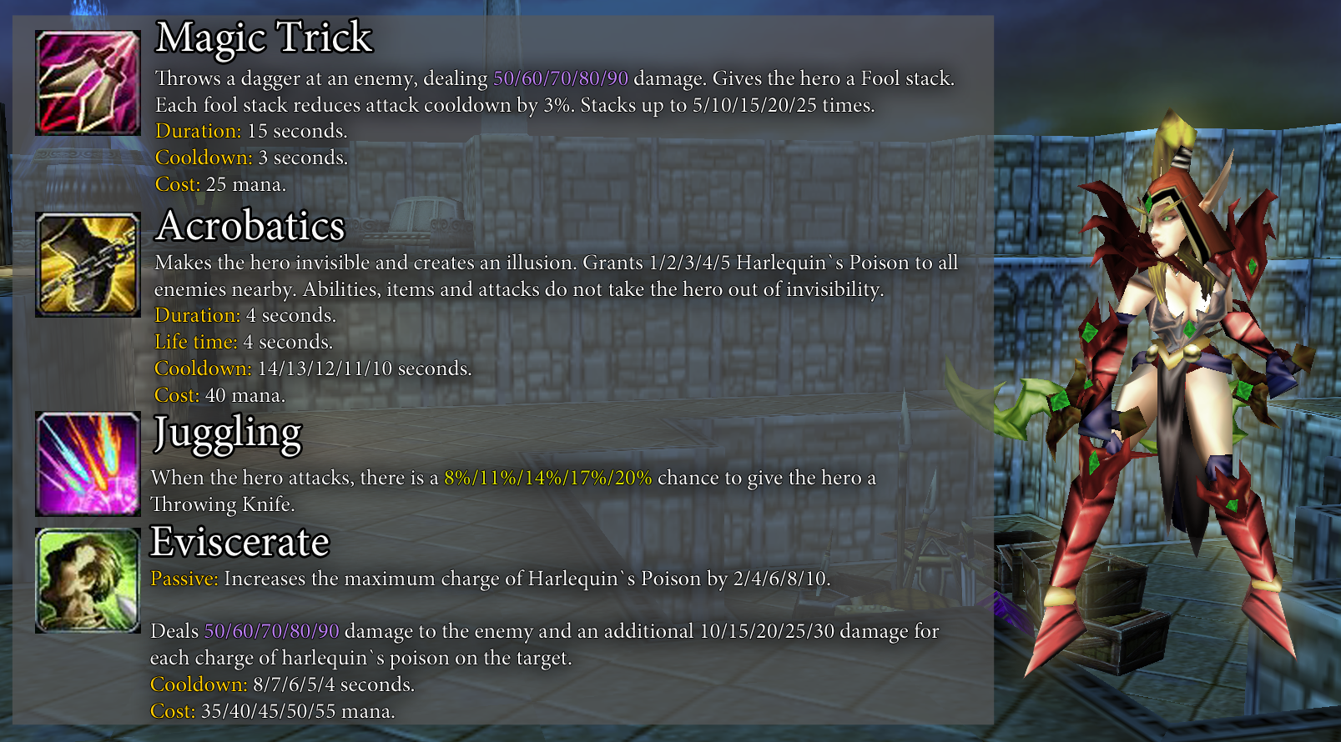



- Armsmaster:

Spar: Duration: 4=>6.

Weapons Training: Damage bonus: 2=>5.

**OTHER**

______________________________

- The "Tarot Card: Emperor" and "Elixir of Acumen" artifacts now display progress in the item description.

- Changed the interface for the quartermaster.

**BUGS**

______________________________

- Fixed an issue that caused the "Potion 'Plasebo'" ability to work incorrectly.

Boss Battle 1.4.3a (26.03.21)  
_________________________________________________________

[Our discord server](https://discordapp.com/invite/KVfrcby)

[Patreon](https://www.patreon.com/bbwc3)

 - Made with community feedback.

**OTHER**

______________________________

- Increased the delay in initializing players' progress to the original value.

- Now "-load" command loads all progress bonuses, except for artifacts in rotation.

**BUGS**

______________________________

- Fixed an issue that caused the "Vampire blood" artifact to break the ability gain on the Q key.

- Fixed a graphical issue that caused the "Void Glaves" projectiles to fire at the wrong angle.

Boss Battle 1.4.3 (25.03.21)  
_________________________________________________________

[Our discord server](https://discordapp.com/invite/KVfrcby)

[Patreon](https://www.patreon.com/bbwc3)

 - Made with community feedback.

**ITEMS**

______________________________

- Added a new item:

|  | Teddy bear | When you summon a minion, it increases its attack power by 5. If it is a sheep, it also doubles its attack power and health. |
| --- | --- | --- |



- Idol of Ridicule: Now reduces gold received by 90%, up from 100%.



- Necklace of Balance: Renamed to "Amulet of Balance".



- Superbot-3000: Cooldown: 60=>90. Life time: 60=>90.



- Spirit figurine: Rarity: Rare=>Legendary.



- Knight Armor: Renamed to "Knight Spaulders".

- The next artifacts are now rare:

Alchemy gift

Blood gift

Crystal gift

Mech gift

Moon gift

Nature gift

Ring gift

Rune gift

Weapon gift

Bloody Mary

**HEROES**

______________________________

- Added new hero: Armsmaster (Defender).

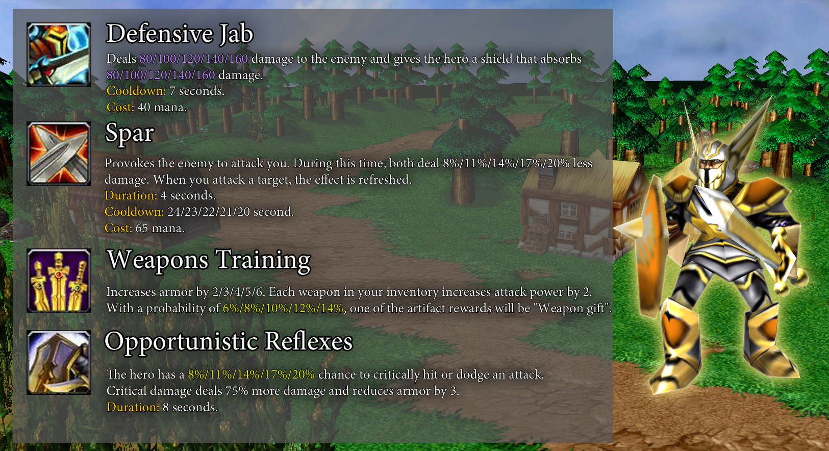



- Demonan:

Dirty trick can no longer stun or damage. Now it only apply negative effects.

Demolition: Now also imposes a dirty trick on the target.

Bad things: Now deals damage first and then applies a dirty trick. Damage: 100/125/150/175/200=>125/150/175/200/225.

Color gunpowder: Chance: 10%/15%/20%/25%/30%=>15%/20%/25%/30%/35%.



- Ghoul King:

Pinnacle of Darkness: Cooldown: 30=>20.

Vendetta of Death: Ghoul Spawn Cooldown: 10/9/8/7/6=>5. Cost: 100/105/110/115/120=>70/75/80/85/90. Cooldown: 60=>60/55/50/45/40.



- Troll Mage:

Orb life time increased from 20 to 30 seconds.

Dextrous vapours: Mana restoring: 10/15/20/25/30=>15/20/25/30/35.

Embolden: Cooldown: 12=>8. Damage bonus: 25%/50%/75%/100%/125=>30%/60%/90%/120%/150%.

Arcane strike: No longer creates orbs. Chance: 50%/60%/70%/80%/90%=>100%. Cost: 110/115/120/125/130=>100/105/110/115/120.



- Skeleton Lord:

Skeleportation: Cooldown: 20/18/16/14/12=>16/15/14/13/12. Range increased from 600 to 900.

Parish: Cooldown: 16/15/14/13/12=>12.



- Soul Reaper:

Death to all living things!: Damage: 100/175/250/325/400=>160/220/280/340/400.

Harvest: Soul stats: 20%/40%/60%/80%/100%=>40%/55%/70%/85%/100%.

Soul rapture: Vampirism: 5%/10%/15%/20%/25%=>10%/15%/20%/25%/30%.



- Strange Dog:

Ravenous Bite: Effect changed: "Deals 100/150/200/250/300 damage to the target. If the target is a minion with health less than 50%, restores 8% of the maximum health and mana and also resets the cooldown of this ability. Cooldown: 12 seconds. Cost: 35/40/45/50/55 mana."

Caustic Leap: Duration: 5=>10.

Blight: Duration: 5=>10.

Pandemic: Effect changed: "Deals damage equal to 8% of the hero's maximum health to all enemies in a large area. If the target's health is 50% or less, restores the hero's health equal to the damage done. Cooldown: 10/8/6/4/2 seconds. Cost: 40 mana."



- Sludge:

Adaptation: The position of the bonuses has been changed:

Level 1 - 400 range attack.

Level 2 - 3 armor.

Level 3 - 3 health regeneration.

Level 4 - 40 movement speed.

Level 5 - 20% spell resistance.



- Combat Ogre:

Crush: Bonus damage: 20%/30%/40%/50%/60%=>20/40/60/80/100.



- Plague Doctor:

Unreachable: Chance: 25%=>40%.



- Divine Maiden:

Blessings: Healing: 50/75/100/125/150=>75/100/125/150/175.

Resurrection: Cost: 150=>120.



- Mermaid:

Seal of fate: Cooldown: 9/8/7/6/5=>13/12/11/10/9.



- Living Altar:

Drain Life: Healing: 8/9/10/11/12=>3/4/5/6/7. Mana restoring: 2/3/4/5/6=>3/4/5/6/7.



- Soulstealer:

Soul Latch: Damage bonus: 1%/2%/3%/4%/5%=>3%. Time between improve: 4=>3/2.5/2/1.5/1.

Immortality: Hits before bonus: 8=>6.

Power Drain: Effect changed: "When another hero dies, heals your hero for 20%/35%/50%/65%/80% of health and mana and grants a shield that absorbs 200/300/400/500/600 damage."

Debilitating Presence: Now also grants the hero a shield that absorbs damage equal to the damage dealt.



- Grim Ninja:

Shadow Strike: Cooldown: 10=>12.

Shuriken Throw: Effect changed: "Throws 3 shurikens forward. Each shuriken deals 35/45/55/65/75 damage. If one of the projectiles deals damage, the effect repeats after 2 seconds. Cooldown: 20/19/18/17/16 seconds. Cost: 50 mana."

Shinobi Mastery: Effect changed: "When the hero deals damage to a target with a health reserve of 25%/30%/35%/40%/45% or less, this damage will be critical. Critical damage deals 75% more damage."



- Sun King:

Solar Eclipse: No longer resurrects the hero and does not increase intelligence when the effect ends.



- Commander:

Strong spirit: The effect is now cumulative.

**BOSSES**

______________________________



- Horseman of the Apocalypse: At 70% health: No longer creates fire waves every second. Added new ability: "Every 15 seconds, creates an area that, after 3 seconds, infuriates all creatures inside. If the target is a hero, the frenzy effect lasts 10 seconds."



- Rabbit: The rabbit now lives for 20 seconds and then dies. Rage mode now activates at 30% health and lasts 1 minute.

**BONUSES**

______________________________



- Curse: Reincarnation: Cooldown: 60=>20.

**OTHER**

______________________________

- Added a system for banning heroes. Now, if you are the host, you can ban up to four heroes for the current game.

- Added a new skin for the hero: Armsmaster (lv.6).

- Reduced total cooldown of potions from 10 to 5 seconds.

- The delay before using the ability has been reduced for all heroes to 0.25 seconds.

- The "Dream catcher" artifact no longer resets cooldown when globally resetting cooldowns on abilities and items.

- The effectiveness of armor is reduced by 33%.

**BUGS**

______________________________

- The Moon, Alchemy, Blood and Crystal sets now work correctly when changing souls.

- Fixed an issue that caused the "Solar Eclipse" ability to not properly turn off Night Mode if the hero dies or activates the ability while under dual use effects.

- The "Fixed Odds" ability no longer works during a duel.

- Fixed an issue that prevented the "Gnomish Soulspin" artifact from having a cooldown on use.

- Fixed an issue that caused stun effects applied while attacking to reduce damage dealt to 0.

- Fixed an issue that caused the difficulty of additional arenas to occur at the wrong time.

- Fixed a bug that caused the "Mountain giant" boss to keep moving while applying a huge hit.

- Fixed an issue that caused the "Rabbit" boss to become easier after being defeated in a fight.

- The "Battle golem" boss will no longer attack totems.

- The "Idol of Pride" artifact no longer works in duels.

- The "Pentagram" artifact now stops working if your hero is dead.

Boss Battle 1.4.2i (19.03.21)  
_________________________________________________________

[Our discord server](https://discordapp.com/invite/KVfrcby)

[Patreon](https://www.patreon.com/bbwc3)

 - Made with community feedback.

**OTHER**

______________________________

- The "Bindings of Potential" artifact effect now works before scaling other items, rather than after.

**BUGS**

______________________________

- Fixed an issue that prevented the "Horror" ability from working correctly.

Boss Battle 1.4.2h (18.03.21)  
_________________________________________________________

[Our discord server](https://discordapp.com/invite/KVfrcby)

[Patreon](https://www.patreon.com/bbwc3)

 - Made with community feedback.

**HEROES**

______________________________



- Sun King:

Heating Up: Cooldown: 10=>12.

Solar Eclipse: Cooldown: 130/120/110/100/90=>300/270/240/210/180. Cost: 200=>300. Now increases 1 intelligence instead of 2.

Boss Battle 1.4.2g (18.03.21)  
_________________________________________________________

[Our discord server](https://discordapp.com/invite/KVfrcby)

[Patreon](https://www.patreon.com/bbwc3)

 - Made with community feedback.

**HEROES**

______________________________



- Sun King:

Solar Flare: Damage bonus: 25%/50%/75%/100%/125%=>30%/40%/50%/60%/70%.

Stasis: Duration: 3/4/5/6/7=>4.

**BUGS**

______________________________

- Fixed an issue that caused some books and runes to not work.

- Fixed an issue that could cause the "Charge" ability to work incorrectly.

Boss Battle 1.4.2f (18.03.21)  
_________________________________________________________

[Our discord server](https://discordapp.com/invite/KVfrcby)

[Patreon](https://www.patreon.com/bbwc3)

 - Made with community feedback.

**ITEMS**

______________________________

- Added new items:

|  | Gnomish Soulspin | Mech. Activation: Restores **30%** health and mana to all heroes and swaps their souls. Cooldown: 30 seconds. |
| --- | --- | --- |
|  | Demonic Warglaive | Weapon. Increases attack speed and spell power by 10%. Each hit of the hero deals an additional **20** magic damage. |
|  | Heat Seekers | Mech. Every 10 seconds, creates a homing missile that flies at a random enemy and deals **125** damage. The effect is repeated for each other mech. |
|  | Crystal Barrier | Weapon. Every 30 seconds, imposes a barrier on the hero, which reduces the damage taken by 15% and the attacks of enemies deal damage to them equal to their damage done. If the hero has an active "Crystal" set bonus, applies a shield to all heroes. Duration: 10 seconds. |
|  | Prophet mask | Blood. Activation: Increases attack power by 15, armor by 3 and gives **20%** vampirism for your attacks, but the hero loses 15 health per second. Re-activation turns off the effect. Cooldown: 10 second. Cost: 75 health. |
|  | Magician's Boots | Increases mana and movement speed by 80. Activation: Changes the positions of your hero and another hero. Cooldown: 10 seconds. Cost: 50 mana. |
|  | Vine Trap | Nature. Activation: Creates a trap that immobilizes the enemy for 3 seconds. Coldown: 20 seconds. Cost: 50 mana. Random bonus. |



- Wabbajack: Now uses a random level 3 ability instead of level 5.



- Rubedo the Beautiful: Renamed to "Rubedo's Belt". The artifact is no longer part of the "Ring" set.



- Glass of wine from Toussaint: Lifetime: 45=>90. Cost: 100=>75.



- Chronos Cursed Clock: Charge: 18=>15.



- Sunflower: Added a random bonus.



- Vampire blood: Effect changed: "Increases damage dealt by 40% if there are no artifacts of legendary rarity in the inventory. Random bonus."



- Insatiable flame: Decrease in cost: 2=>3.



- Idol of Greed: Now also increases health by 1000.

**HEROES**

______________________________

- Added a new hero: Sun King (Encourager).

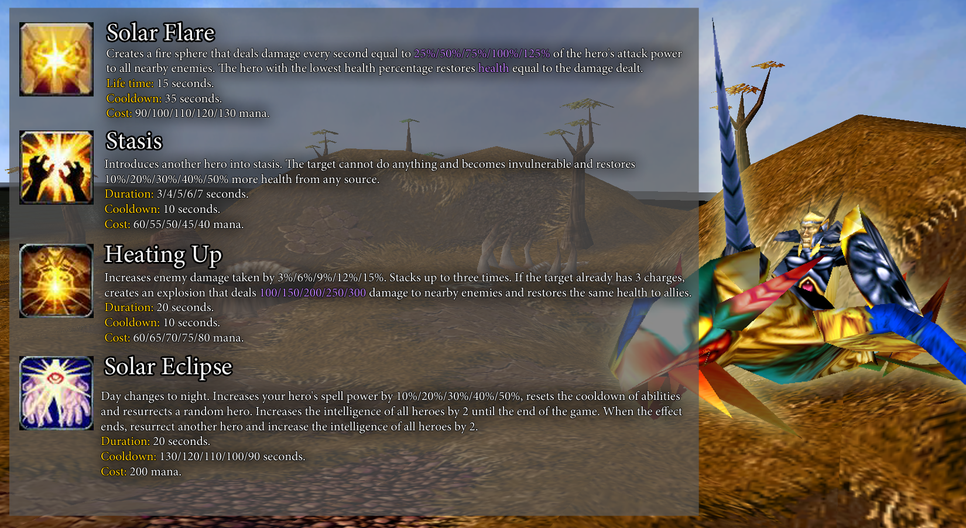



- Fallen One:

Unearthly Beauty: Now grants "Tarot Card: Wealth" at level 5 instead of "Rubedo the Beautiful".



- Metal Mage:

Slayer: Cooldown: 3=>5. Cost: 40=>65.

**BOSSES**

______________________________



- Manipulator: Now changes souls not immediately, but after 3 seconds.



- Pit Lord: Magic Damage Taken: -20%=>-40%. Added new ability: "Removes a random item from each hero's inventory and teleports them to hero rooms."

**BONUSES**

______________________________



- Fiery rain: Cooldown: 60=>45. Life time: 12=>15.

**OTHER**

______________________________

- Icons for some mods have been changed.

- The probability of triggering a random event is slightly reduced.

- The "Knight's Box" artifact has been removed from the "Spiritualists" guild artifact rotation.

- Attempts now stop giving gold after using the third attempt.

- Changed the system of imposing stun on the target.

- The base probability of obtaining an artifact of legendary rarity is reduced by 1%, and of rare rarity by 4%.

**BUGS**

______________________________

- Fixed a visual issue that prevented the "Mods" window from disappearing when you abandon a hero.

- The "Elixir of Longevity" artifact no longer works on creatures summoned by the "Split" ability.

- Fixed a bug due to which receiving and depriving artifacts during the change of souls did not work correctly.

- Fixed a bug due to which items could sometimes not be removed to the battlefield.

Boss Battle 1.4.2e (13.03.21)  
_________________________________________________________

[Our discord server](https://discordapp.com/invite/KVfrcby)

[Patreon](https://www.patreon.com/bbwc3)

 - Made with community feedback.

**ITEMS**

______________________________



- Cloud horn: Now summons 30% less sheeps.



- Idol of Envy: Magic damage bonus: 50%=>75%.



- Idol of Sin: Healing bonus: 50%=>75%.



- Runestone Mandom: Cooldown bonus: 7%=>25%.

**HEROES**

______________________________

- Added new hero: Mephistar (Marauder).

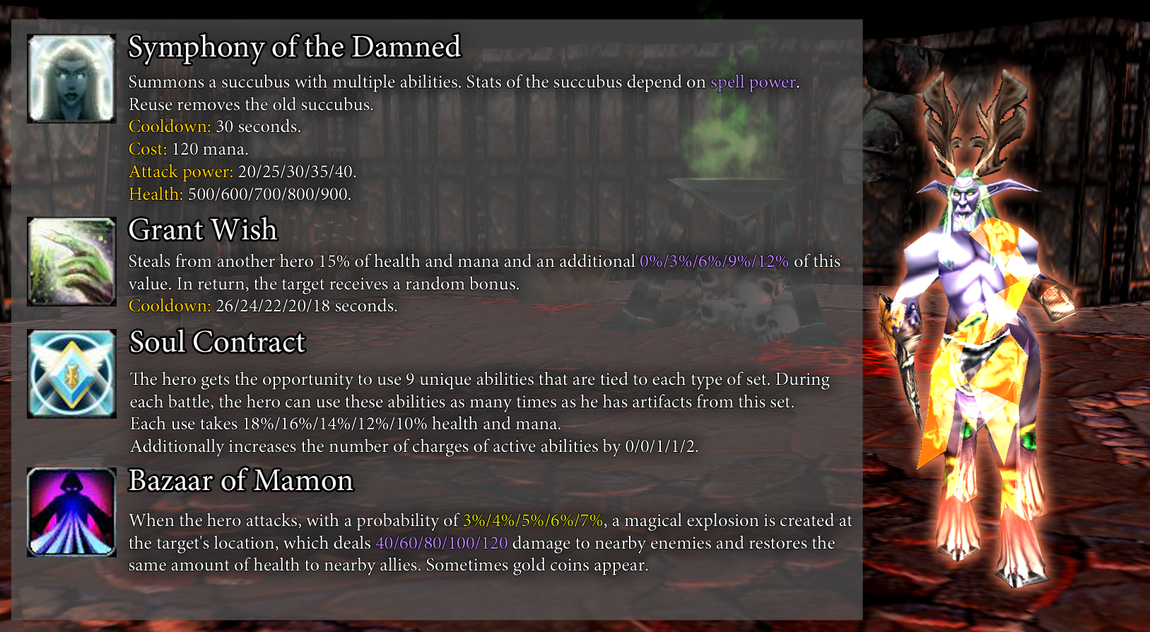



- Chronomancer:

Paradox: Effect changed: "Deals 15/20/25/30/35 damage to the enemy every second. Stacks up to three times. Duration: 15 seconds. Cooldown: 10 seconds. Cost: 50/55/60/65/70 mana."

Chrono acceleration: Cooldown: 20=>15.



- Living Altar:

Ascendance: Cost: 60/50/40/30/20=>0. Cooldown: 20/18/16/14/12=>13/11/9/7/5.

Drain Life: The primary and secondary modes are reversed. Again.

**BONUSES**

______________________________

- Added new bonus:

|  | Seeker | Every 30 seconds, creates a projectile that slowly flies towards a random hero. When the projectile hits the target, it stuns it for 2 seconds and takes 10% of its health. |
| --- | --- | --- |

**OTHER**

______________________________

- Changed the interface for choosing difficulty, mods, rotation of artifacts and extra modes.

**BUGS**

______________________________

- Fixed an issue that caused the "Spirit figurine" artifact to work incorrectly when changing an artifact in the inventory.

- Fixed a bug due to which the notification about the completion of the task of the guild "Instigators" did not work correctly.

- Fixed an issue that prevented the "Mixture of illusions" artifact from working when the caster was at full health.

- Angry Pig can no longer be summoned to duels.

Boss Battle 1.4.2d (07.03.21)  
_________________________________________________________

[Our discord server](https://discordapp.com/invite/KVfrcby)

[Patreon](https://www.patreon.com/bbwc3)

 - Made with community feedback.

**ITEMS**

______________________________

- Added new items:

|  | Star in a bottle | Moon. Alchemy. Instead of the usual effect, the Fire Potion deals massive damage and additional damage equal to **3%** of the health of enemies. Random bonus. |
| --- | --- | --- |
|  | Bandit's Box | Activation: Corrupted. Forges a bandit artifact. |
|  | Idol of Ridicule | The hero takes 40% less physical damage, but can no longer receive gold. |
|  | Gift bag | Activation: Corrupted. Forges a gift. |
|  | Bandit Hood | When the hero is attacked, there is a **15%** chance of dodging the attack. If the inventory contains “Bandit Jacket” and “Bandit Silent Steps”, it turns into “Bandit Armor”. |
|  | Bandit Jacket | When the hero attacks, there is a **15%** chance to deal critical damage. Critical damage deals 75% more damage. If the inventory contains “Bandit Hood” and “Bandit Silent Steps”, it turns into “Bandit Armor”. |
|  | Bandit Silent Steps | When the hero attacks, there is a **15%** chance to stun the target for 1 second. If the inventory contains “Bandit Hood” and “Bandit Jacket”, it turns into “Bandit Armor”. |



- Mask of Dagoth Ur: "Enemies are much more likely to attack the hero. Every 8 seconds, gives all heroes a buff that cancels the next damage taken."



- Cloud horn: Sheep under your control are now summoned.



- Explosive moss: Added a random bonus.

**HEROES**

______________________________

- Added new hero: Fallen One (Weakening).

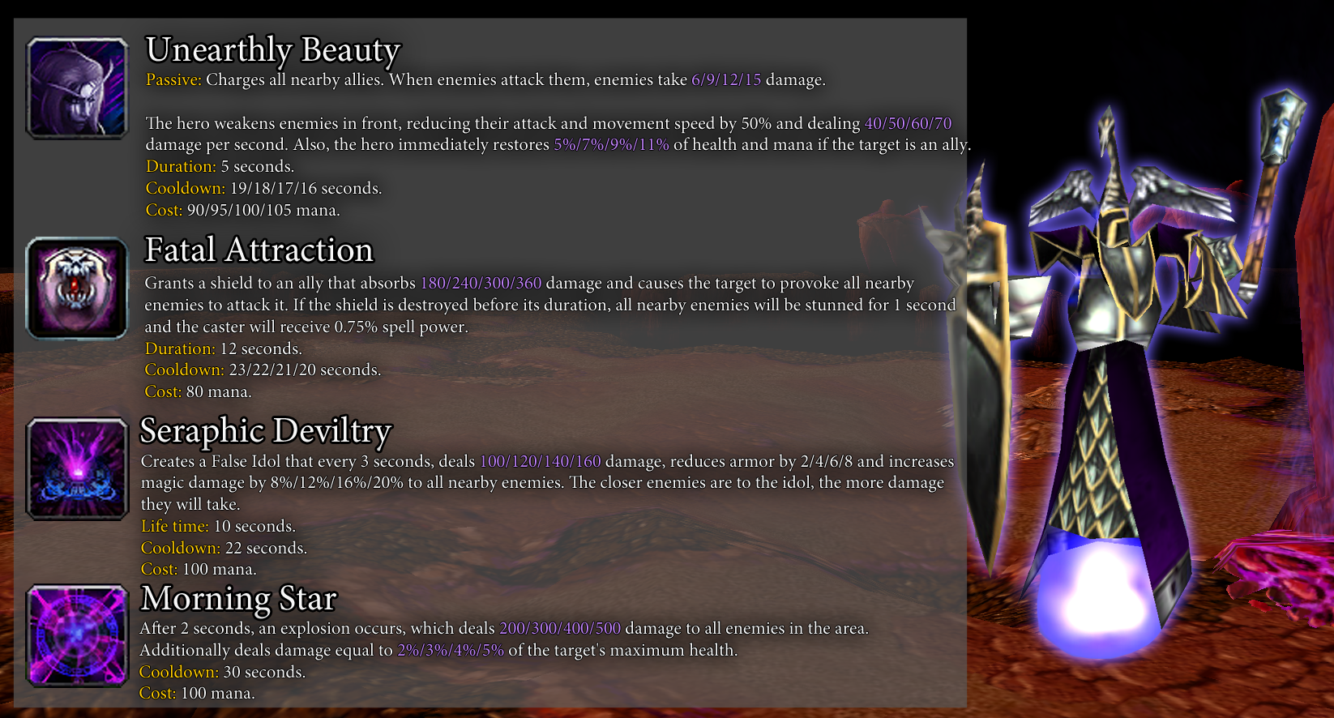



- Living Altar:

Drain Life: The primary and secondary modes are reversed.



- Chronomancer:

Distortion: Icon changed.

**OTHER**

______________________________

- The "Bloody Mary" artifact has been removed from the rotation of items that can be purchased from the Instigators guild.

**BUGS**

______________________________

- Fixed a bug due to which the "Serrated blade" artifact may not work correctly.

- The "Rubedo the Beautiful" artifact no longer works in duels.

Boss Battle 1.4.2c (06.03.21)  
_________________________________________________________

[Our discord server](https://discordapp.com/invite/KVfrcby)

[Patreon](https://www.patreon.com/bbwc3)

 - Made with community feedback.

**ITEMS**

______________________________



- Mask of Dagoth Ur: Effect changed: "Enemies are much more likely to attack the hero. Every 8 seconds, it gives the hero a buff that cancels the next damage taken."



- Fulfillment of will: Quest: 17=>15.



- The beginning of the hunt: Quest: 50=>40.

**HEROES**

______________________________



- Living Altar:

Blood Mend: Cooldown: 5=>8.

Drain Life: Healing: 8/10/12/14/16=>8/9/10/11/12.

**BOSSES**

______________________________



- Blade master: At 20% and 40%: Heal per kill: 20=>60.

**OTHER**

______________________________

- Merchant "Great huckster Tom" now sells a limited number of gifts.

- Relics are no longer classified as artifacts of common rarity.

**BUGS**

______________________________

- Fixed an issue that could cause DPS to go negative.

- Fixed an issue that caused the yellow player's creatures to be allied to enemies.

Boss Battle 1.4.2a (02.03.21)  
_________________________________________________________

[Our discord server](https://discordapp.com/invite/KVfrcby)

[Patreon](https://www.patreon.com/bbwc3)

 - Made with community feedback.

**ITEMS**

______________________________



- Midas Ring: Rarity: Rare=>Legendary. The item now provides less gold.

**HEROES**

______________________________



- Toxic Elemental: Hero icons and model have been changed.



- Treasure hunter:

Renamed to "Pirate".

Bomb toss: Effect changed: "Throws a bomb at an enemy that stuns enemies nearby nearby and deals 120/160/200/240/280 damage. Duration: 1.5/2/2.5/3/3.5 seconds. Cooldown: 18 seconds. Cost: 50/55/60/65/70 mana."



- Chronomancer:

Distortion: Effect changed: "Every 60/55/50/45/40 seconds, resets the cooldown of abilities and artifacts. When the hero uses an ability or item, reduces the cooldown by 1 second."

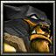

- Barbarian:

Blood bath: Effect changed: "Deals 200/250/300/350/400 damage to the enemy. Each hit of the hero reduces the cooldown of the ability by 1 second. Cooldown: 20 seconds. Cost: 35 mana."



- Dryad:

Call of nature: Now summons 1 creature. Cooldown: 30=>18.

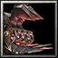

- Meat Wagon:

Unholy Greed: Cooldown: 4=>7.

Take My Money!: Now generates 40% less gold.



- Soulstealer:

Now the main stat of the hero is Intelligence.

**BUGS**

______________________________

- Fixed a bug due to which the abilities "Corpse Toss" and "Take My Money!" conflicted with each other.

- Fixed an issue that caused the "Parasitism" ability to work incorrectly when reused on a target.

- The "Power Drain" ability now correctly grants a shield charge.

- Fixed a bug due to which items generated by the ability "Take My Money!" could appear behind the arena.

Boss Battle 1.4.2 (01.03.21)  
_________________________________________________________

[Our discord server](https://discordapp.com/invite/KVfrcby)

[Patreon](https://www.patreon.com/bbwc3)

 - Made with community feedback.

**ITEMS**

______________________________



- Icethorn: Shield Bonus: 25%=>20%. Removed random bonus.



- Felweed: Removed random bonus.



- Banner: Effect changed: "When the hero attacks, with a probability of 2%, it increases the random stat."



- Conqueror's Helmet: Rarity: Common=>Rare.



- Amulet of Souls: Cooldown: 60=>30.



- Necklace of Balance: Cooldown: 60=>40.



- Majyte: Rarity: Legendary=>Rare. Spell power bonus: 200%=>100%. Cost: 125=>75.

**HEROES**

______________________________

- Added a new hero: Meat wagon (Marauder).

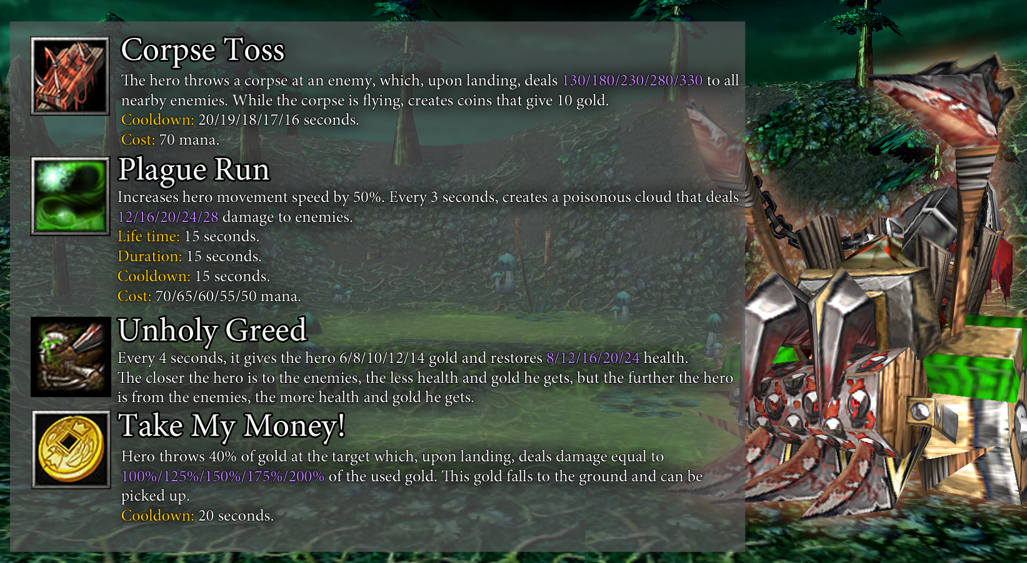



- Evil spirit: Changed hero icon.



- Black Knight: Renamed to "Bone knight".



- Living altar:

Ascendance: Added description about modifiable abilities.



- Strange dog:

Caustic Leap: Cost: 70=>65/60/55/50/45.



- Apex Predator:

Aqua Jet: Cost: 70=>55.

Origin Pulse: Cost: 100/90/80/70/60=>60.



- Pyrolord:

Mega blast: Ability removed.

Added new ability: Fire arrows. Creates 3/4/5/6/7 fire homing arrows, each dealing 60 damage. Cooldown: 15 seconds. Cost: 90 mana.



- Grim ninja:

Shadow Strike: Cooldown: 20/19/18/17/16=>10.

Shinobi Mastery: Now always triggers if the target's health is 40% or less.

Smoke bomb: Cost: 80=>60.



- Dream Devourer:

Nightmares: Cooldown: 24=>20.

Devour: Now increases the random stat by 2. Cooldown: 30/28/26/24/22=>30/29/28/27/26.

Mental deprivation: Damage: 300/400/500/600/700=>450/575/700/825/950.



- Vampire:

True form: No longer reduces strength. Cooldown: 45=>65.



- Money Bag:

Vore: Cost: 60=>40.

Composure: Armor bonus: 2/3/4/5/6=>2/4/6/8/10. Gold bonus: 3%/6%/9%/12%/15%=>4%/8%/12%/16%/20%.

Digest: Gold: 15/25/35/45/55=>24/36/48/60/72.



- Commander:

Mark of the Chosen: Duration: 15=>20. Cooldown: 8=>5.

Retribution: Duration: 30=>60.

Strong spirit: Cost: 60/65/70/75/80=>60.



- Soulstealer:

Soul Latch: Cooldown: 10/9/8/7/6=>2. Cost: 35=>15.

Immortality: Cost: 75=>60. Cooldown: 28/26/24/22/20=>20.

Power Drain: Also grants a shield equal to the health gained.



- Lord of Chaos:

Hallucinations: Cooldown: 12=>10. Cost: 30/35/40/45/50=>40.

Despicable: Cooldown: 12=>10. Cost: 30/35/40/45/50=>40.

Illusions: Cooldown: 12=>10. Cost: 30/35/40/45/50=>40.

**BOSSES**

______________________________



- Evil totem: No longer considered a mechanism.



- Mechanic: Now uses a random activated mech (mech power: 3 mechs).

**BONUSES**

______________________________

- Added new bonus:

|  | Favorable events | Random events happen more often. |
| --- | --- | --- |

**OTHER**

______________________________

- Solo players can now gain experience if the map was launched through "Custom Games".

- The instigator's guild healing bonus has been reduced from 10% to 5%. The bonus for completing the task has been reduced from 5% to 2% and luck from 4 to 2. The difficulty of completing the task has been reduced from 3000 health to 1000.

- Added backup system for your progress. Now when you update your progress, a file with your current progress will be created in a separate folder.

- Added new skins: Metal Mage (Lvl. 8), Mentor (Lvl. 12), Barbarian (Lvl. 16), Sludge (Lvl. 18), Minotaur (Lvl. 20), Divine Maiden (Lvl. 21), Admiral (Lvl. 25).

- DPS calculation parameter has been changed. Now the calculation is based on damage for the last 10 seconds of the battle, and not the entire match.

**BUGS**

______________________________

- Fixed a bug due to which the artifacts "Dream catcher", "Mecha chicken W.T.I.I." and "Norepinephrine" triggered effects that are triggered when using abilities or items.

- Fixed an issue that caused the "Farik the Tricky" artifact to not work correctly when changing souls.

- Fixed an issue where the "Ascendance" ability could be reset when using items.

- Fixed an issue where watching a replay could break your current gameplay.

- Fixed an issue that caused some player item collections to not work correctly.

Boss Battle 1.4.1m (23.02.21)  
_________________________________________________________

[Our discord server](https://discordapp.com/invite/KVfrcby)

[Patreon](https://www.patreon.com/bbwc3)

 - Made with community feedback.

**ITEMS**

______________________________



- Might of the Damned: Attack power bonus: 100%=>70%.

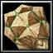

- Spiked Shield: Now deals magic damage.



- Arthur the Pure: Added a random bonus.



- Bloody rose: Healing: 20%=>10%.

**HEROES**

______________________________



- Incarnation of the Void:

 Space Distortion: Clot damage: 10/15/20/25/30=>20/25/30/35/40.



- Crystal mimic:

Parasitism: Cooldown: 10=>12. Cost: 40=>60.



- Preacher of the light:

Calm Field: Ability cooldown is no longer reduced at level 5 of the ability.

**BOSSES**

______________________________

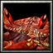

- Crab: Health: 8000=>10000.



- Rabbit: Now spawns bosses near the main boss. Now starts summoning minions immediately.



- Manipulator: Health: 7500=>10000. Attack power: 80=>55. This boss can appear again on hard difficulty.

**BONUSES**

______________________________



- Fatigue: The negative effect is now easier to see.



- Steadfastness: Damage threshold: 25%=>40%.



- Equality: Health taken: 10%=>20%.

**OTHER**

______________________________

- In the "Fast start" modifier you can now see the descriptions of the selected artifacts.

- Now healing abilities and items that trigger on a random target only work on creatures with less than full health.

- The animation of the death of the "Explosive lump" minion has been changed.

**BUGS**

______________________________

- Fixed an issue that caused the "Ascendance" ability to work incorrectly with invisibility effects.

- Fixed an issue where "Blood Infusion" was not counting as a buff.

- Fixed an issue where the "Space Distortion" ability was dealing less damage than it should have.

- Fixed an issue where using the "Space Distortion" and "Abyssal Decimation" abilities would reset the current skin to the base skin of the hero.

- Fixed an issue where the "Fortuneteller deck" and "Sandro's personal items" artifacts could offer the same artifacts.

- Fixed an issue where the shadows of the "Evil totem" boss could not work correctly.

- Fixed an issue that prevented "Intoxication" from working if acquired during combat.

- Fixed an issue where the "Leap" and "Caustic Leap" abilities, which were used as random, would cause some heroes to have incorrect heights.

- Fixed a bug due to which one of the arrows of the "Void Glaves" ability was acting less than it should.

Boss Battle 1.4.1i (17.02.21)  
_________________________________________________________

[Our discord server](https://discordapp.com/invite/KVfrcby)

[Patreon](https://www.patreon.com/bbwc3)

ITEMS

______________________________

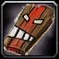

- Relic: Witch Doctor's Mask: Effect changed: "Elemental energy gives 2 elements to enemies, one of which will always be "Fire"."

HEROES

______________________________

- Added new hero: Living Altar (Healer).

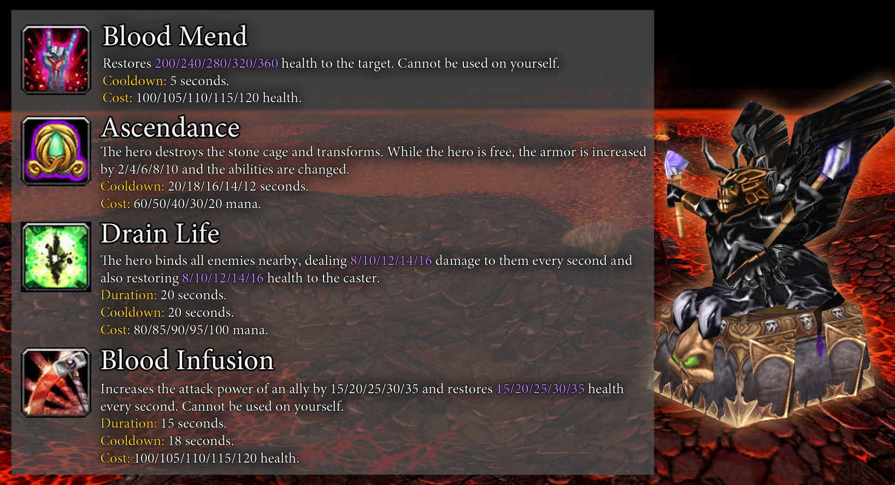

OTHER

______________________________

- Removed the sound of crickets on the map.

- Improved enemy behavior.

BUGS

______________________________

- Fixed an issue that caused the "Chaos Earring" artifact to have its old effect.

Boss Battle 1.4.1h (10.02.21)  
_________________________________________________________

[Our discord server](https://discordapp.com/invite/KVfrcby)

[Patreon](https://www.patreon.com/bbwc3)

ITEMS

______________________________

- Added new item:

|  | Mage's Box | Activation: Corrupted. Forges a mage artifact. |
| --- | --- | --- |



- Prismatic lens: Cost: 100=>50.

OTHER

______________________________

- The "Digest" ability has been removed from the random ability rotation.

BUGS

______________________________

- Corrected damage calculation for "Resonates" and "Revived Blood" artifacts.

- Fixed an issue that caused the "Slayer" ability to reduce active charges from any damage instead of physical damage.

- The "Sheep's Tear" artifact can no longer be obtained from the rotation of activated artifacts.

- Fixed an issue where the "Slippers of Madness" artifact could provide more stats than it should have.

- The "Midas Ring" and "Discount coupon" artifacts no longer provide gold upon destruction of relics.

- Fixed an issue where the "Bloody mark" artifact could create a copy of your hero.

Boss Battle 1.4.1g (06.02.21)  
_________________________________________________________

[Our discord server](https://discordapp.com/invite/KVfrcby)

[Patreon](https://www.patreon.com/bbwc3)

ITEMS

______________________________

- Added new item:

|  | Spirit figurine | Moon. Summons a small uncontrollable spirit that chases the hero and constantly attacks nearby enemies, dealing 15 damage. This spirit also uses waves created by the "Moon" set bonus. |
| --- | --- | --- |

HEROES

______________________________



- Black Knight:

Hard bone: Effect changed: "Increases hero's armor by 10/14/18/22/26 and magic resistance by 20%/30%/40%/50%/60%, but reduces attack and movement speed by 70%. Duration: 15 seconds. Cooldown: 24 seconds. Cost: 45 Mana."

OTHER

______________________________

- Added new command "-load". This command loads your save file.

- Added 3 new skins: Adventurer (lvl. 10), Harpy (lvl. 17), Preacher of the light (lvl. 19).

BUGS

______________________________

- Fixed an issue where the creature summoned by the "Glass of wine from Toussaint" artifact could not attack bosses.

- Fixed a bug due to which the unit "Banner" (purple player) did not work correctly.

- Fixed an issue that caused the "Tarot Card: World" artifact to not work correctly if triggered multiple times in a battle.

- Fixed an issue where the "Mimic potion" artifact would not work correctly with other "Forge" artifacts.

Boss Battle 1.4.1f (03.02.21)  
_________________________________________________________

[Our discord server](https://discordapp.com/invite/KVfrcby)

[Patreon](https://www.patreon.com/bbwc3)

ITEMS

______________________________

- Added new items:

|  | Bloody rose | Blood. Nature. When the hero attacks, heals the hero **20%** health from the damage done. If health is full, gives a **shield** that absorbs damage instead. |
| --- | --- | --- |
|  | Glass of wine from Toussaint | Blood. Activation: Summons a powerful vampire. Sometimes a vampire can be drunk. Life time: 45 seconds. Cooldown: 45 seconds. Cost: 100 mana. |
|  | Mage Pants | Increases mana regeneration by 150%. If the inventory contains “Mage Robe” and “Mage Shoes”, it turns into “Mage Armor”. |
|  | Mage Robe | Increases mana by 125. If the inventory contains “Mage Pants” and “Mage Shoes”, it turns into “Mage Armor”. |
|  | Mage Shoes | Increases spell power by 10%. If the inventory contains “Mage Pants” and “Mage Robe”, it turns into “Mage Armor”. |
|  | Battle halberd | Weapon. Reduces hero's armor by 7. When the hero attacks, reduces the target's armor by 7. Duration: 7 seconds. |

HEROES

______________________________



- Divine maiden:

Blessings: The target limit is set - 10 allies.

BUGS

______________________________

- Fixed an issue where the "Slayer" ability was not working correctly.

Boss Battle 1.4.1e (01.02.21)  
_________________________________________________________

[Our discord server](https://discordapp.com/invite/KVfrcby)

[Patreon](https://www.patreon.com/bbwc3)

ITEMS

______________________________

- Added new items:

|  | Celestial Quartz | Crystal. Activation: Increases mana by 20. Cooldown: 60 seconds. Cost: 100 mana. |
| --- | --- | --- |
|  | Goblin manual | Activation: Corrupted. Increases stats by 1. If the hero has at least 1 mech, replaces uniques into "Keen mind". |
|  | Sheep bait | Common. Activation: Increases attack power by 8 and health by 150 for all sheeps under your control. Cooldown: 30 seconds. Cost: 50 mana. |
|  | Mechanical relay | Mech. When the hero takes damage, with a **15%** chance, deals **30** damage to all nearby enemies. Increases damage by 15 for each other mech in the inventory. |
|  | Karti the Straight | Ring. Each 7th attack deals 3 times more damage. Random bonus. |
|  | Crown of Night | Moon. While the hero is invisible and during the time after invisibility, any damage will be critical, dealing 75% more damage. Duration: 6 seconds. Random bonus. |

HEROES

______________________________



- Minotaur:

Wrath: Cooldown: 6=>8.

OTHER

______________________________

- Guild ability bonus "Magic Blast" (Spellcasters) is now increased by 50 damage, instead of 100.

BUGS

______________________________

- Fixed an issue that could cause Knight Armor to combine in 1-2 pieces.

Boss Battle 1.4.1d (30.01.21)  
_________________________________________________________

[Our discord server](https://discordapp.com/invite/KVfrcby)

[Patreon](https://www.patreon.com/bbwc3)

ITEMS

______________________________



- Soul of Determination: The artifact is back in the game. Effect changed: "If all other heroes die, corrupted, increases stats of your hero by 5 and resurrects all heroes."

OTHER

______________________________

- Added preview.

- Improvement of stats: Number of levels: 20=>5.

- The ability of the guild "Elementalists" (Elemental energy) has been changed: "At the beginning of each battle, charges all enemies with a random element. Each of the elements weakens the target. Effect bonus - 10%."

- Added new skin for dryad (Lvl. 15).

BUGS

______________________________

- Fixed an issue where the shadow zones of the "Dark sorcerer" boss could suddenly appear under players, killing them within seconds.

Boss Battle 1.4.1с (27.01.21)  
_________________________________________________________

[Our discord server](https://discordapp.com/invite/KVfrcby)

[Patreon](https://www.patreon.com/bbwc3)

ITEMS

______________________________



- Soul of Determination: Artifact removed.

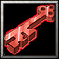

- Key: Artifact removed.



- Runestone Mandom: Effect changed: "Increases armor by 5 and health by 500. Decreases attack speed by 25% and increases cooldown of abilities by 7%."



- Staff of Purity: Charge: 6=>4.

HEROES

______________________________



- Shoggoth:

Glimpse of Madness: Ability removed.

Writhing Mass: Ability removed.

Refashion: Ability removed.

Added new abilities:

Lashing Out. Curses all enemies in front of the hero, dealing 100/150/200/250/300 damage and immobilizing them. While the effect is active, when these creatures attack your hero, you deal damage to them equal to your attack power. Duration: 5 seconds. Cooldown: 20/19/18/17/16 seconds. Cost: 75 mana.

Dark Whispers. Charges the hero with dark energy, every second deals 16/24/32/40/48 damage to nearby enemies and reduces their armor by 2/3/4/5/6. Duration: 15 seconds. Cooldown: 25 seconds. Cost: 80 mana.

Path of Horror. Increases hero attack power by 10/20/30/40/50, armor by 2/4/6/8/10 and spell power by 20%/30%/40%/50%/60%. Duration: 30 seconds. Cooldown: 45 seconds. Cost: 100 mana.



- Preacher of the light:

Calm Field: Damage and healing: 20/30/40/50/60=>16/24/32/40/48.



- Toxic Elemental:

Water Recedes: Cooldown: 20=>20/19/18/17/16. Damage and healing: 200/250/300/350/400=>150/200/250/300/350.

Raging Bane: Cost: 80=>45.



- Cool Wicerd:

Nah-ice!: Damage: 50/75/100/125/150=>100/130/160/190/220. Duration: 6/8/10/12/14=>12.

BOSSES

______________________________



- Rabbit: Health: 30000=>45000.



- Knight spirit: Health: 6000=>7000.



- Pyromancer: Health: 20000=>28000. Added new ability: "Every 12 seconds, creates a huge firestorm that deals 75 damage every second."

OTHER

______________________________

- The "Sacrifice agreement" artifact has been removed from the corrupted item rotation.

- Now battle limit activated 40% more often.

- Guilds no longer give gold.

BUGS

______________________________

- Ability "Calm Field" now has the correct size.

- Fixed an issue that caused the effect of the "Tarot Card: Plague" artifact to give a lifesteal effect.

- Fixed an issue where the ability "Calm Field" could sometimes cause permanent silence on the target.

Boss Battle 1.4.1b (25.01.21)  
_________________________________________________________

[Our discord server](https://discordapp.com/invite/KVfrcby)

[Patreon](https://www.patreon.com/bbwc3)

ITEMS

______________________________



- Necromancer pendant: The stats of the summoned skeleton are increased by 40%. The skeleton now has the Provocation ability.

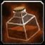

- Norepinephrine: Cooldown: 1=>1.2.

BOSSES

______________________________



- Sea savage: Lines are now activated 50% faster. Lines now spawn at 80% boss health. Health: 35000=>42000.

BUGS

______________________________

- Fixed an issue that prevented the effect of the "Soul rapture" ability to disappear.

- Fixed a visual issue that caused the ability to select a skin for those heroes that did not have skins.

- Fixed an issue that caused the "Offhand shooting" ability to work incorrectly with the "Norepinephrine" artifact.

Boss Battle 1.4.1 (24.01.21)  
_________________________________________________________

[Our discord server](https://discordapp.com/invite/KVfrcby)

[Patreon](https://www.patreon.com/bbwc3)

ITEMS

______________________________

- The set membership, name and icon of many artifacts have been changed:

| Old icon | Old name | Old set | New icon | New name | New set |
| --- | --- | --- | --- | --- | --- |
|  | Pshix's bubbling cocktail | **Alchemy** |  | Pshix the Explosive | **Ring** |
|  | Catnip | **Nature** |  | Love potion | **Alchemy** |
|  | Tricky wisdom fish | **Alchemy** |  | Fahrenheit | **Ring** |
|  | Stun ore | **Alchemy** |  | Filzer the Fair | **Ring** |
|  | Kaboom-  365 | **Mech** |  | Albedo the Hellish | **Ring** |
|  | Soul swirl | **Mech** |  | Amulet of Souls | - |
|  | Stribog | **Ring** |  | Plate gauntlets | - |
|  | Harry the Wyrmtongue | **Ring** |  | Sunflower | **Nature** |
|  | Azerite | **Crystal** |  | Vampire Sign | **Blood** |
|  | Savior spirit | **Moon** |  | Night sage | **Nature** |
|  | Zirik, chatty spirit | **Moon** |  | Runestone Zirik | **Rune** |
|  | Celia, the spirit of hope | **Moon** |  | Light of life | **Nature** |
|  | Roseleaf | **Nature** |  | Might of the Damned | **Blood** |
|  | Symbol of Cenarius | **Nature** |  | Night crab | **Moon** |
|  | Luckleaf | **Nature** |  | Gold fish | **Alchemy** |
|  | Anger flower | **Nature** |  | Werewolf blood | **Blood** |
|  | Necrotree Seed | **Nature** |  | Prismatic lens | **Crystal** |
|  | Golden clover | **Nature** |  | Ladybug | **Alchemy** |
|  | Sacrificial altar | **Blood** |  | Deadly spores | **Nature** |
|  | Chamomile | **Nature** |  | Mana needle | **Moon** |
|  | Fire in a bottle | **Alchemy** |  | Revived Blood | **Blood** |
|  | Potion of Solitude | **Alchemy** |  | Spring water | - |
|  | Lorder's badge | - |  | Elune's Glyph | **Moon** |
|  | Witch brew | **Alchemy** |  | Runestone Pan | **Rune** |
|  | Symbol of Uther | - |  | Sun root | **Nature** |
|  | Particle of the sun | - |  | Ring of Light | **Ring** |
|  | Big red button | **Mech** |  | Big red button | - |
|  | Bloody stone | **Blood** |  | Ruby diamond | **Crystal** |
|  | Glass tooth | **Moon** |  | Glass tooth | **Alchemy** |
|  | Twilight lamp | **Moon** |  | Twilight lamp | - |
|  | Magic fern | **Nature** |  | Magic fern | **Moon** |
|  | Poison | **Alchemy** |  | Poison | - |
|  | Philosopher's Stone | **Alchemy** |  | Omnipotent Ruby | **Blood** |
|  | Nekrowool | **Alchemy** |  | Nekrowool | - |
|  | Heart of the Lady of the Lake | **Crystal** |  | Heart of the Lady of the Lake | **Moon** |
|  | Ancient Pearl | - |  | Ancient Pearl | **Crystal** |
|  | Stone mosaic | - |  | Runestone Mos | **Rune** |
|  | Saronite bomb | - |  | Saronite bomb | **Mech** |

- The following artifacts have been removed from the map:

Manaburner

Buggy engine

Cursed ring

Portable chronomaly

Bloodstream

Sacrifice stone

Tamed lightning

Zirik, chatty spirit

Armornut

Elfist

Enchanted stone

Beer

Angels tears

Witch brew

Poisonous firefly

Summoning Stone

Nephritis

Arena Rules

Doubloon

Golden horseshoe

Goldfinch

Matter of Form

Thief sign

Demonic Hole

Wormhole

All-seeing eye

Cat foot

Cursed Amulet

Seal of the Dead

Staff of Darkness

Mithril

Healing Ring

Inspirational Ring

Protective Ring

Vicious Ring

Elemental Ring



- Elixir of Longevity: Effect changed: "Activation: Restores 100 health to all nearby allied minions and permanently increases their attack power by 15%. Cooldown: 20 seconds. Cost: 35 mana."

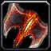

- Desperado's Hatchet: Attack power: 7=>0.



- Pshiks the Explosive: Effect changed: "Activation: Stuns the target for 2 seconds. If uniques is already upgraded, stuns for 8 seconds instead. Cooldown: 35 seconds. Cost: 45 mana."

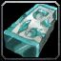

- Runestone Zirik: Rarity: Legendary=>Rare. Effect changed: "At the end of the battle gives a random artifact. If this artifact is of rare or legendary quality, increases stats by 5, otherwise, it decreases stats by 2."



- Runestone Pan: Effect changed: "At the end of the battle, gives a random bonus."



- Superbot-3000: Effect changed: "Activation: Summons Superbot-3000. When summoned, it upgraded for each mech in the inventory. Life time: 60 seconds. Cooldown: 60 seconds. Cost: 25 mana."



- Autonavigator: Effect changed: "Activation: Summons uncontrollable minion that attack the enemy. Summons an additional minion for each mech in your inventory. Life time: 30 seconds. Cooldown: 45 seconds. Cost: 50 mana."



- Rik the Greedy: Damage and healing: 60=>100.



- Plush doll: Rarity: Rare=>Common.



- Pentagram: Rarity: Rare=>Common.



- Blood of the Ancient: Cost: 100=>25.



- Living Mana: Rarity: Legendary=>Rare.



- Moon owl: Added a random bonus.



- Deadflower: Effect changed: "When any hero dies, restores 20% of the maximum health and mana to all allied heroes. Random bonus."



- Infusion of Infinity: Added 2 random bonuses.



- Resonates: Rarity: Legendary=>Rare.



- Staff of Phenomenal Power: Rarity: Legendary=>Rare.



- Prism: Rarity: Rare=>Common.

HEROES

______________________________



- Scarab King:

Sap: Cooldown: 20/18/16/14/12=>15. Duration: 0.9=>0.3.



- Samurai:

Charged blade: Cooldown: 4=>7.

OTHER

______________________________

- Added a new random event - sheep dealer.

- Now you can see how much experience you got at the end of the game.

- Added 2 new skins for heroes: Druid-Naturalist (Lvl. 11), Black Knight (Lvl. 13).

BUGS

______________________________

- Fixed an issue that prevented Poison Touch from working with effects that would trigger on target death.

Boss Battle 1.4k (20.01.21)  
_________________________________________________________

[Our discord server](https://discordapp.com/invite/KVfrcby)

[Patreon](https://www.patreon.com/bbwc3)

ITEMS

______________________________

- Added new items:

|  | Rubedo the Beautiful | Ring. The first corrupted artifact in battle is not destroyed. |
| --- | --- | --- |
|  | Enchanted Thorium | Increases the chance of receiving artifacts-rewards of improved rarity by 2%. Random bonus.  Random bonus. |
|  | Tarot Card: Chameleon | Activation: Corrupted. Increases stats by 1. All items in inventory get the effect: "At the beginning of each battle, it turns into a random activatable artifact." |
|  | Tarot Card: Rarity | Activation: Corrupted. Increases stats by 1. All the next reward artifacts will be of increased rarity. |



- Book of Legends: Stats: 2=>1.

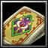

- Tarot Card: Jule: Stats: 2=>1.



- Tarot Card: Oblivion: Stats: 2=>1.



- Elixir of Acumen: Stats: 2=>1.

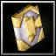

- Cyber book: Stats: 2=>1.

BUGS

______________________________

- Fixed an issue that caused skins to work incorrectly with a random hero pick.

- Fixed an issue that prevented the level 1 progression system from working visually.

Boss Battle 1.4j (18.01.21)  
_________________________________________________________

[Our discord server](https://discordapp.com/invite/KVfrcby)

[Patreon](https://www.patreon.com/bbwc3)

ITEMS

______________________________

- Added new items:

|  | Azerite | Crystal. Increases the attack and movement speed of the hero by 30%. Reduces the attack and movement speed of allies near the hero by 30%. |
| --- | --- | --- |
|  | Visarius the Follower | Ring. When the hero uses 4 different abilities or items in a row, restores **10%** of the maximum health and mana. |
|  | Life Ring | Ring. Every 15 seconds, restores the hero **5%** health and mana. |
|  | Hunter Badge | Activation: Summons 5 hostile target dummies.  Life time: 30 seconds. Cooldown: 30 seconds.  Cost: 50 mana. |

OTHER

______________________________

- Modifiers "Chaos!", "More chaos!" and "More! More chaos!" no longer have -30% experience bonus.

- Now in the "Double trouble" modifier, you can use Huckster's "Throw dice", but the 50% gold bonus no longer works for this action.

BUGS

______________________________

- Fixed an issue where the "Fixed Odds" ability might not work correctly when changing souls.

Boss Battle 1.4i (16.01.21)  
_________________________________________________________

[Our discord server](https://discordapp.com/invite/KVfrcby)

[Patreon](https://www.patreon.com/bbwc3)

ITEMS

______________________________

- Added new items:

|  | Cosmic reed | Nature. Activation: Deals damage to the enemy equal to **25%** of the health that your hero has restored during this battle. Cooldown: 45 seconds. Cost: 80 mana. |
| --- | --- | --- |
|  | Midas Ring | Ring. Activation: Select the artifact in inventory. Turn it into gold. The higher the rarity of the artifact, the more gold you get. |
|  | Elixir of Longevity | Alchemy. Activation: Restores **100** health to all nearby allied minions and increases their life time by 8 seconds. Coldown: 20 seconds. Cost: 35 mana. |
|  | War Banner | Increases the attack power of all allies by 15%. |

HEROES

______________________________



- Mentor:

Gifting: Cooldown: 19/18/17/16/15=>25/24/23/22/21.



- Thunderous Nomad

Lightning energy: Bonus damage to one target: 50%/90%/130%/170%/210%=>30%/45%/60%/75%/90%.



- Barbarian:

Counterattack: Ability removed.

Added new ability: Recklessness. The hero goes into a rage. Hero increases attack speed by 30%/45%/ 60%/75%/90%, but loses 9/10/11/12/13 mana every second. If there is no mana, it spends health instead. Cooldown: 15 seconds.

Blood bath: Effect changed: "Takes bleeding on the enemy, dealing 200/250/300/350/400 damage over a certain time. Each hit of the hero reduces the cooldown of the ability by 1 second. Duration: 10 seconds. Cooldown: 20 seconds. Cost: 35 mana."

OTHER

______________________________

- Added a new skin system. You can choose a skin for the hero at the beginning of the game. At the moment, skins can be obtained with a certain level of progress. Also, 3 skins were added: for a samurai (lv.5), a monk (lv.7) and a minotaur (lv.9).

- Added a new random event: Box of gold.

- Ability "Rebirth" has been removed from the rotation of random abilities.

BUGS

______________________________

- Fixed an issue that caused player progress to desync after reaching level 21.

- Fixed an issue that caused the "Book of Legends" artifact to work incorrectly when rolling items.

Boss Battle 1.4h (12.01.21)  
_________________________________________________________

[Our discord server](https://discordapp.com/invite/KVfrcby)

[Patreon](https://www.patreon.com/bbwc3)

ITEMS

______________________________



- Exchange Totem: Now grants 2 secondary stats instead of 1.



- Raging fire: Effect changed: "Activation: Deal damage to the enemy equal to 10% of the maximum health of the target. Cooldown: 40 seconds. Cost: 200 mana."



- Plush doll: Cost: 75=>45.

HEROES

______________________________



- Skeleton Lord:

Skeleton life time: 12=>15.



- Metal Mage:

Slayer: Cost: 35/40/45/50/55=>40.

Iron Maiden: Cooldown: 20=>14.

Metallica: Cost: 100/110/120/130/140=>60/65/70/75/80.



- Moon Owl:

Unity with moon: Effect changed: "The hero is one with the moon. While the effect is active, each time the hero uses an ability or item, it restores 16/20/24/28/32 mana. Duration: 20 seconds. Cooldown: 35 seconds."

BOSSES

______________________________



- Rabbit: Now summons minions every 15 seconds, up from 25.



- Pit Lord: Health: 18000=>22000.

OTHER

______________________________

- The bonus for the "Guardsmen" ability has been reduced from 3% to 2%.

- Now enemies who stand still more often attack heroes.

- The "Double trouble" modifier now grants a 15% bonus to experience.

BUGS

______________________________

- Fixed an issue that caused dummies to remain allied during and after PvP combat.

Boss Battle 1.4g (11.01.21)  
_________________________________________________________

[Our discord server](https://discordapp.com/invite/KVfrcby)

[Patreon](https://www.patreon.com/bbwc3)

ITEMS

______________________________



- Chaos Earring: Effect changed: "You deal double damage against enemies with full health. Random bonus."

BUGS

______________________________

- Fixed a visual bug due to which some icons with descriptions worked incorrectly.

- Fixed an issue where the "Magic Amplifier" artifact might not work correctly.

Boss Battle 1.4f (10.01.21)  
_________________________________________________________

[Our discord server](https://discordapp.com/invite/KVfrcby)

[Patreon](https://www.patreon.com/bbwc3)

ITEMS

______________________________



- Saronite bomb: Now deals magic damage.



- Libram of Knowledge: Added a random bonus.



- Void Orb: Added 2 random bonuses.

HEROES

______________________________



- Preacher of the light:

Calm Field: Ability radius increased by 150%. Cost: 100/115/130/155/160=>70/75/80/85/90.

Touch of the Light: Cost: 100/115/130/155/160=>70/75/80/85/90.

Justice strike: Cost: 100/115/130/155/160=>70/75/80/85/90.



- Combat ogre:

Crush: Cost: 50=>35.

Earthquake: Cost: 50=>35.



- Lord of Chaos:

Madness: Added a new "something".

BOSSES

______________________________



- Poisonous evil: Poisonous areas now deal 10x damage to minions. 50% health: Poison Damage: 30=>50. 75% health: The damage threshold has been shifted from 75% to 85%. Cooldown of creating an area with toxin: 8=>5.

BUGS

______________________________

- Fixed a visual bug due to which the description of the last boss was not displayed.

- The "Energy Orbs" ability now works with the spell power bonus for the uniques abilities.

- Fixed an issue that caused the "Tarot Card: Moon" artifact to not completely fill the inventory with artifacts.

Boss Battle 1.4e (09.01.21)  
_________________________________________________________

[Our discord server](https://discordapp.com/invite/KVfrcby)

ITEMS

______________________________



- Afflicted blade: Attack power: 25=>20.



- Aggressive Shield: Strength: 3=>0.



- Chakrum: Attack speed: 12%=>10%. Intelligence: 6=>3.

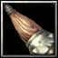

- Club ogre: Intelligence: -5=>-7.



- Heavy ax: Chance: 15%=>10%.



- Hook Hands: Bonus damage: 15%=>10%.



- Katana: Bonus Damage Limit: 40=>30.



- Lo'Gosh's Shield: Armor: 2/4/6/8/10=>1/2/3/4/5. Attack power: 10%/20%/30%/40%/50%=>8%/16%/24%/32%/40%.

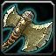

- Divider: Life time: 15=>10.

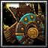

- Great Tree Shield: Duration: 30=>18.



- Ogre Staff: Intelligence: 8=>4.



- Spellbreaker shield: Armor: 3=>0.



- Spiked Shield: Strength: 8=>4.



- Desperado's Hatchet: Attack power: 15=>7.



- Blockade: Damage reduction bonus: 15%=>10%.

HEROES

______________________________



- Crystal Mimic:

Crystal Barrage: Damage: 100/150/200/250/300=>80/120/160/200/240.

BOSSES

______________________________



- Poisonous evil: Health: 18000=>22000.



- Knight in strange armor: The boss's ability damage and attack power have been doubled. Attack speed reduced by 20%. Added a new ability at 30%, 50% and 70% health: "At this time, zones appear under the heroes, which explode after 2 seconds and deal 200 damage."



- Ice Dragon: Ballista damage to boss: 8%=>8.5%.

OTHER

______________________________

- Added a new random event: "Knowledge Merchant".

- The multiboard no longer automatically opens when winning or losing.

- Added in-game database for artifacts that are in the set.

- Progress system properties have been changed.

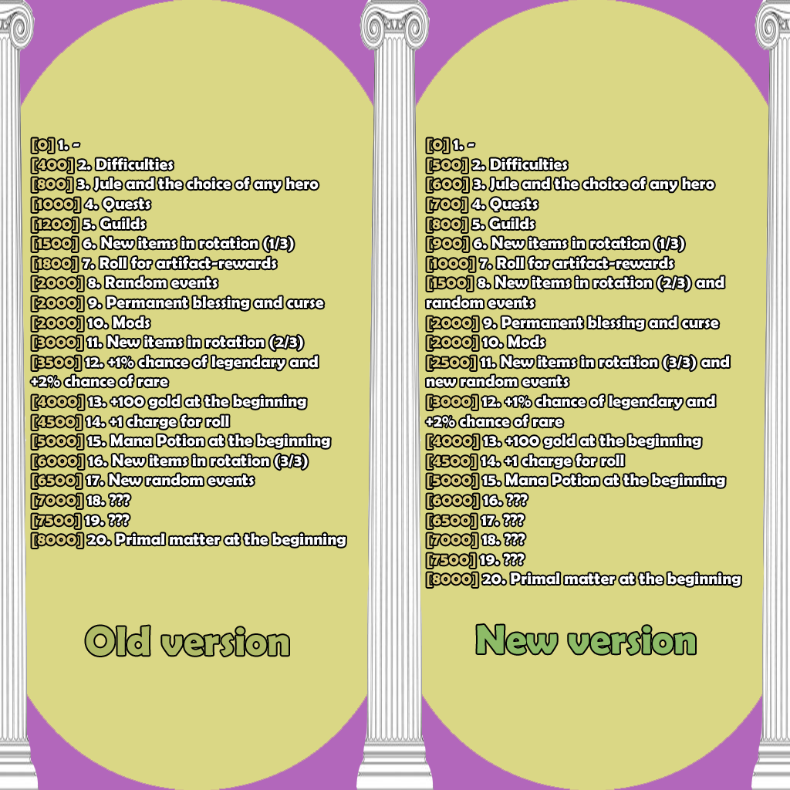

BUGS

______________________________

- Fixed an issue that caused the "Tarot Card: World", "Tarot Card: Hermit", "Credit Card" and "Book of Legends" artifacts to cause players to desync. Also, now these artifacts can be used in battle.

- Fixed an issue that caused the "Aggressive Shield" artifact to ignore the invulnerability of bosses to taunt.

- Fixed an issue that prevented "Void Glaves" ability to work with spell power.

Boss Battle 1.4d (07.01.21)  
_________________________________________________________

[Our discord server](https://discordapp.com/invite/KVfrcby)

ITEMS

______________________________

- Added new item:

|  | Phoenix Badge | Activation: Imposes a buff on an ally. When this effect ends, returns the target back in time (at the time the effect was applied). Duration: 5 seconds. Cooldown: 40 seconds. Cost: 75 mana. |
| --- | --- | --- |



- Cloud horn: Life time: 15=>30. Now summons 10 more sheep.

OTHER

______________________________

- Players now gain 40% more experience for defeat.

- Now in "Newbie" mode, enemies are 25% weaker instead of 15%. Also, this mode is now turned off at the fifth level, instead of the third.

BUGS

______________________________

- Fixed a visual error due to which the description of the "Knight in strange armor" boss could appear in the informant after the first boss was whitewashed.

- Fixed a bug that caused the "Gefest" artifact to work incorrectly.

- Fixed a bug that caused the battle to end incorrectly if the difference between the rotation of legendary artifacts and legendary artifacts in the inventories of heroes exceeded the specified limits.

Boss Battle 1.4c (06.01.21)  
_________________________________________________________

[Our discord server](https://discordapp.com/invite/KVfrcby)

ITEMS

______________________________



- Royal letter: Effect changed: "Activation: Corruption. Gives a corrupted artifact. If there are no other artifacts in the inventory, fills the inventory with corrupted artifacts."

HEROES

______________________________



- Crystal Mimic:

Parasitism: Damage to bosses: x0.3=>x0.1.



- Thunderous Nomad:

Chain Lightning: Cost: 60=>75.

OTHER

______________________________

- Added display of the current level and experience at the beginning of the game and in the "Data" button.

BUGS

______________________________

- The "Vore" and "Divine Intervention" abilities no longer work if the target to which the bind is going has the "Soul of Determination" artifact.

Boss Battle 1.4 (04.01.21)  
_________________________________________________________

[Our discord server](https://discordapp.com/invite/KVfrcby)

ITEMS

______________________________

- Added new items:

|  | Soul of Determination | When the hero takes fatal damage and is not the only living hero in the arena, instead of dying, the hero remains with 1 health.  If all other heroes die, destroys this artifact and resurrects all heroes. |
| --- | --- | --- |
|  | Magic fern | Nature. When another hero dies, increases your spell power by 2.5%. |
|  | Gaze Burning Totem | Activation: Creates a gaze burning totem. Every 3 seconds, it deals **100** damage to a random target. If the target's health is 50% or less, summon a random minion. Duration: 30 seconds. Cooldown: 1 second. Cost: 75 mana. |
|  | Witch's love | Alchemy. At the beginning of the fight, creates a witch's cauldron, which gradually restores health and mana. Random bonus. Random bonus. |
|  | Runestone Zolo | Rune. Your abilities and items have a **20%** chance to critically hit, dealing 75% more damage. Increases cooldown of abilities and items by 15%. |

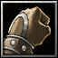

- Fighter's Gloves: Effect changed: "Increases attack speed by 20%."



- Doubloon: Now it no longer stacks several times in a row with the received gold 200 or more.



- Reign of the legend: Condition: 100=>50.



- Explosive moss: Range increased by 50%. Now deals magic damage.



- Idol of Sin: Duration: 8=>5.



- Summoning Stone: Rarity: Legendary=>Rare. Added a random bonus.



- Demonic Hole: Cost: 150=>0.



- Learning Curve: Added a random bonus.

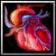

- Twin heart: Health: 1%=>2%.

HEROES

______________________________



- Gambler:

Beginner’s Luck: Now grants 30% more rewards. You can see the rewards received.



- Treasure hunter:

Black mark: Gold: 10/15/20/25/30=>18/24/30/36/42.

BOSSES

______________________________

- Added new boss: Duelist (Lvl. 8), Knight in strange armor (Lvl. 10).

BONUSES

______________________________

- Added new bonuses:

|  | Extra try | You gain +1 charge to your roll. |
| --- | --- | --- |
|  | Counterstrike | The first damage to the enemy does not deal damage. |
|  | Zeal | Cooldown of bosses' abilities reduced by 10%. |
|  | Laziness | Cooldown of abilities and items increased by 7%. |



- Steadfastness: Damage limit: 15%=>25%.

OTHER

______________________________

- Added progress system. Now, some of the content is closed and unlocked as you level up.

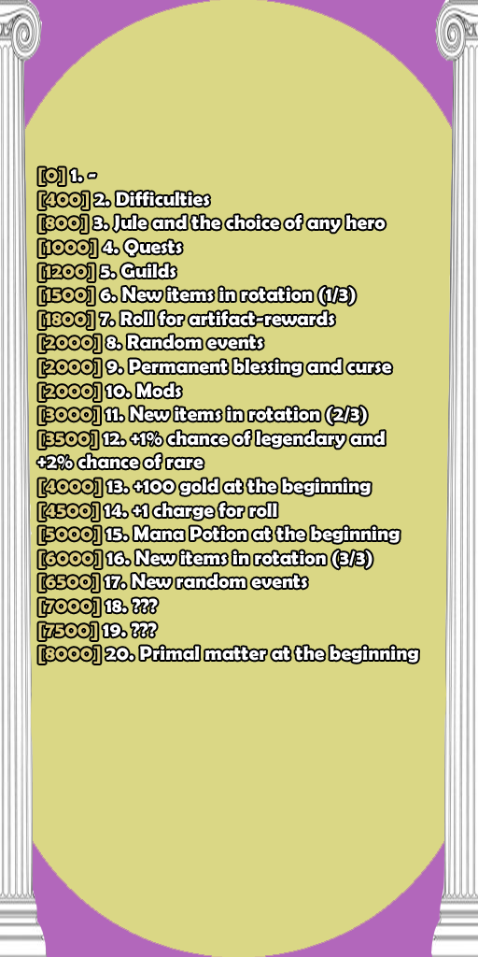

- Now, when you select a guild, other guilds become less visible.

- Removed "-speedrun", "-cancel" and "-roll" commands.

- The condition for joining the "Instigators" guild has been reduced from 1000 to 500.

- The "Feast of Souls" mod has been temporarily removed.

BUGS

______________________________

- The "Tarot Card: World", "Tarot Card: Hermit", "Credit Card" and "Book of Legends" artifacts now only work out of combat.

- The "Soul rapture" ability no longer works in the "Felweed" artifact.

- Fixed an issue that caused the boss icon to remain after losing to the boss in "Double Trouble" mode.

Boss Battle 1.3.6 (28.12.20)  
_________________________________________________________

[Our discord server](https://discordapp.com/invite/KVfrcby)

## ITEMS

______________________________

- All relics cost reduced from 250 to 100 gold. Relics can no longer be exchanged with the Huckster.



- Crystal of Power: Effect changed: "Activation: Your next spell will be massive. While in this effect, your next targeted spell will work on all nearby creatures. Does not work if the caster is the target of the spell. Cooldown: 30 seconds. Cost: 125 mana."



- Sharp deck: Effect changed: "When you pick up a reward artifact, other reward artifacts do not disappear. Random bonus. Random bonus."



- Mechanical clock: Rarity: Rare=>Common. Cooldown bonus: 3%=>4%.



- Steel rose: Rarity: Common=>Rare.

## HEROES

______________________________



- Apex Predator:

Stomp Out: Now knocks creatures away from the hero, instead of at random points. Health: 10/20/30/40/50=>15/25/35/45/55.



- Grim ninja:

Shadow Strike: Now, when the condition is met, the ability not only resets its cooldown, but also does not cost mana.



- Shoggoth:

Glimpse of Madness: Now works for an unlimited number of targets and does not disappear when the hero dies. Cooldown: 40/35/30/25/20=>20. Cost: 0=>40.

Spinal Burst: Now it works in the area.

Refashion: Cost: 50/60/70/80/90=>50.



- Skeleton Lord:

Grasp of the dead: No longer depends on luck and agility.



- Moon owl:

Unity with moon: Mana loss: 10=>8.



- Druid-Naturalist:

Influx: Cooldown: 17/16/15/14/13=>16.



- Plague doctor:

Transformation of prana: Mana loss: 5/8/11/14/17=>5/7/9/11/13.

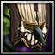

- Miracle alchemist:

Miracle of the elements: Cost: 75=>50.

## BOSSES

______________________________



- Polar bear: Attack power: 75=>90.



- Salamander: Health: 4000=>6000. Damage range and damage over time near the boss are increased by 100%.



- Murloc Chieftain: Health: 1500=>1750.



- Moon priestess: Health: 8000=>10000.



- Mechanic: Health: 8000=>10000.



- Ice Dragon: Glaive Thrower: Attack power: 40=>55.

## BONUSES

______________________________



- Chaos Earring: Effect changed: "When the boss appears, it takes 8% of his health."



- Steadfastness: Damage limit: 10%=>15%.



- Support: Now summons 1 less minion.

## OTHER

______________________________

- The purchase cost of a random artifact has been reduced from 400 to 350 gold.

- Added a new visual effect for low health in combat.

- Now, at the start of every game, random heroes receive a bonus. This bonus is given by "Volcano Potion" if you select this hero. Works only in "All heroes" mode.

- Now you can see which final boss you will fight.

## BUGS

______________________________

- The "Felweed" artifact no longer works with the "Bloody Mary" and "Book of Victims" artifacts.

- Fixed a visual bug due to which the "PvP-battle" button did not display a description.

Boss Battle 1.3.5V (25.12.20)  
_________________________________________________________

Discord server: <https://discordapp.com/invite/KVfrcby>

## ITEMS

______________________________

- Now all gifts that give artifacts from sets, as well as "Wool gifts", have the "forge" tag.



- Bloodstream: Rarity: Legendary=>Rare.



- Exile Skull: Rarity: Rare=>Common.

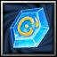

- Wishstone: Rarity: Rare=>Common.



- Gefest: Effect changed: "In every fight, instantly kills the first 4 summoned enemy creatures. Random bonus."



- Mecha chicken W.T.I.I.: Health: 15%=>20%.

- The next artifacts have received a random bonus:

Piece of explosive cake

Drums

Sheep's Tear

Stone mosaic

Symbol of Uther

Thief's Gloves

Trash

Ancient Octopus

Ancient necklace

Pentagram

## HEROES

______________________________



- Crystal Mimic:

Parasitism: Cooldown: 20=>10.

Crystal Barrage: Damage: 150%/200%/250%/300%/350% of attack power=>100/150/200/250/300.

## OTHER

______________________________

- Added the opportunity to change artifact rewards once per selection

- The list of items that are sold in guilds has been changed.

## BUGS

______________________________

- Fixed a bug due to which "Knight Equipment" was not assembled correctly if there was an artifact "Ultimate weapon" in the inventory.

Boss Battle 1.3.5U (23.12.20)  
_________________________________________________________

Discord server: <https://discordapp.com/invite/KVfrcby>

## ITEMS

______________________________

- Added new items:

|  | Insatiable flame | Costs 2 less mana for each ability or item you use while that item is in your inventory. Activation: Deal **1000** damage to the enemy. Cooldown: 45 seconds. Cost: 1000 mana. |
| --- | --- | --- |
|  | Idol of Sin | Your health-restoring abilities and items restore 50% more health. After healing, the target cannot restore health over time. Duration: 8 seconds. |
|  | Essence of time | Alchemy. Reduces the cooldown of abilities and items by 10%. Additionally reduces cooldown by 25% if you only have artifacts from the alchemy set in your inventory. |
|  | Mixture of illusions | Alchemy. When you restore health with potions, it also restores health to other heroes. Random bonus. |
|  | Library card | Every 4rd purchased item in the library gives a random bonus. |

## BONUSES

______________________________

- Added new bonus:

|  | Plot twist | You have 1 additional attempt at a boss fight. |
| --- | --- | --- |

## OTHER

______________________________

- Now bonuses from guild quests for the ability are displayed in the ability itself.

## BUGS

______________________________

- Fixed an issue that could cause textures to get stuck when using the Shadow Strike ability.

- Fixed a bug that caused the "Denial of the Past" ability counter for the data to work incorrectly.

Boss Battle 1.3.5T (21.12.20)  
_________________________________________________________

Discord server: <https://discordapp.com/invite/KVfrcby>

## ITEMS

______________________________

- Added new item:

|  | Serrated blade | Weapon. When the hero attacks, inflicts bleeding on the enemy, which deals damage equal to **8%** of the hero's maximum health over time. Duration: 5 seconds. |
| --- | --- | --- |



- Dream catcher: Effect changed: "When any sheep dies, resets cooldown of your hero’s abilities and items. Cooldown: 18 seconds."

## HEROES

______________________________

- Added new hero: Grim ninja (Killer).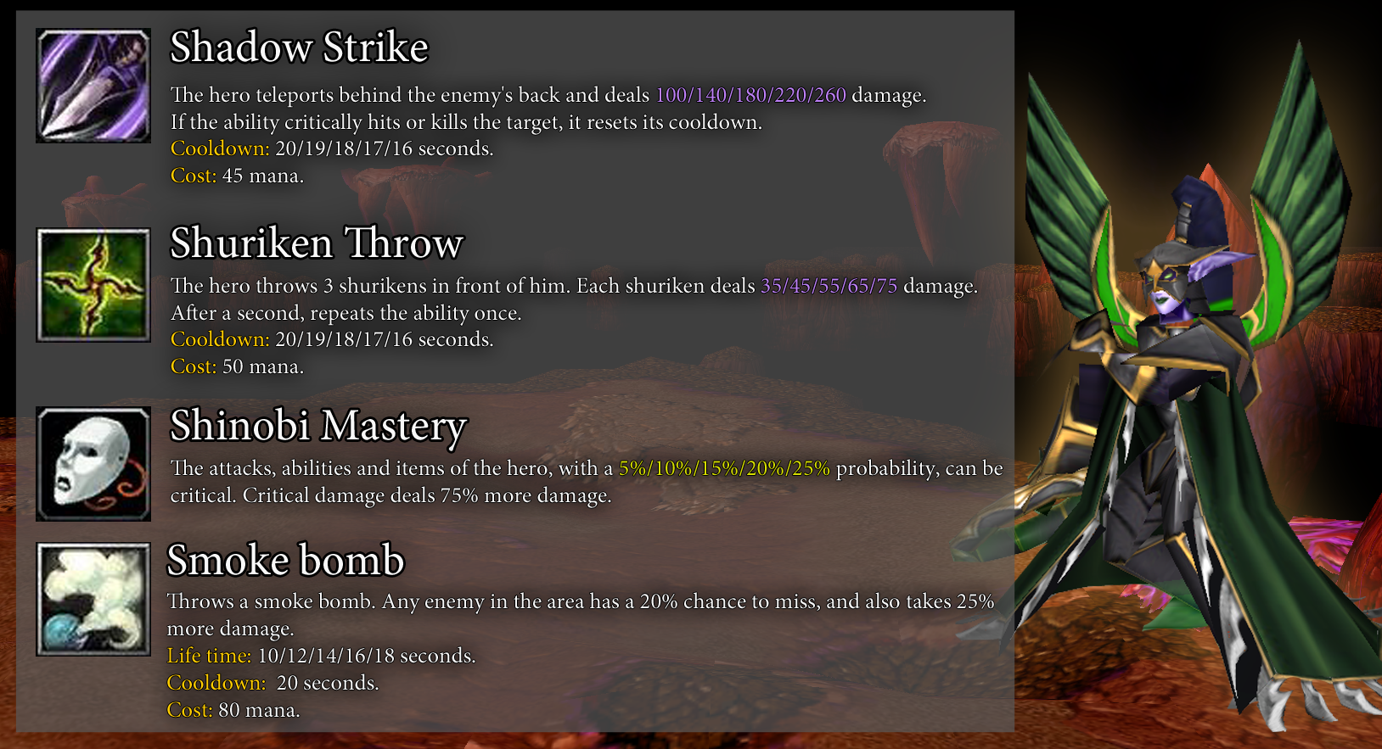

BONUSES

______________________________



- Laboratory equipment: Effect changed: "Increases spell power for potions and uniques, as well as the duration of buffs and debuffs by 25%."

## BUGS

______________________________

- Fixed a bug that caused the summoning of minions in the new arena to work incorrectly.

- Fixed an issue that caused the "Ressurection" ability to work incorrectly.

- Fixed an issue that caused the "Staff of Purity" and "Transforming matter" artifacts to work incorrectly when purchasing potions.

- Fixed an issue that prevented the "Activation" bonus from working.

Boss Battle 1.3.5S (19.12.20)  
_________________________________________________________

ITEMS

______________________________

- Added a new system of random bonuses for items. Now some items will receive a random bonus if they are picked up.

- Added new items:

|  | Blood of the Ancient | Blood. Activation: Gives the hero a buff: "Abilities and items cost health instead of mana." Duration: 15 seconds. Cooldown: 60 seconds. Cost: 100 mana. |
| --- | --- | --- |
|  | Runestone Chad | Rune. Increases attack speed by 90%. Reduces attack power by 90%. |
|  | Lucky Charm | Random bonus. Random bonus. Random bonus. |
|  | Bloody Mary | Blood. Each damage dealt restores **10** health. Random bonus. |
|  | Bursting bullet | Activation: Deals **20** damage to an enemy 15 times. Cooldown: 30 seconds. Cost: 50 mana. |
|  | Bindings of Potential | Any damage you deal below 30 damage now deals 30 damage. Random bonus. |
|  | Mecha chicken W.T.I.I. | Mech. When the hero takes fatal damage, instead of death, restores **15%** of health for each mech in the inventory. Cooldown: 60 seconds. |
|  | Norepinephrine | Alchemy. After the hero's attack, hero cannot take damage over time. Duration: 0.5 seconds. Cooldown: 1 seconds. Random bonus. |
|  | Breastplate of Judgment | Each damage dealt deals 15 more damage. |

- The following items have lost their extra bonuses and received a "Random bonus":

Catalyst

Chamomile

Conqueror's Helmet

Discount coupon

Doubloon

Enchanted Contract

Fire show

Goldfinch

Harry Wyrmtongue

Moon moth

Neophyte mushrooms

Pendant of Elune

Seal of Mana

Silverleaf

Steel rose (two bonuses)

Stun ore

Transforming matter

Tricky wisdom fish

Twilight lamp (two bonuses)

Voodoo-Amulet (two bonuses)

Wild Yeast

Felweed

Hungry leech

Icethorn

Dream catcher

Elfist

Farelo Fiery

Liquid sulfur

Nephritis

Rik Greedy

Witch brew



- Fulfillment of will: Condition: 15=>17. No longer works on bosses "Ser", "Ber" and "Baby Hydra".



- Badge of the Gray Guard: Cost: 200=>150.



- Tesseract: Spell power bonus: 0.4%=>0.3%.



- Staff of Purity: Effect changed: "When you receive an artifact, destroys it and gives you purified matter. Every 6th purifying gives 1 level."

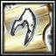

- Power search: Effect changed: "Quest: Split the artifact from each set and each rarity."

## HEROES

______________________________



- Scarab King:

Strengthening: Chance: 20%=>15%.



- Gambler:

Blackjack: Cost: 60=>40.

Double Down: Illusion stats: 50%=>100%. Cost: 30/35/40/45/50 gold=>50 mana.



- Crystal Mimic:

Parasitism: Cost: 100 health=>40 mana. Damage to bosses: x0.1=>x0.3.

Crystal Barrage: Cost: 200 health=>60 mana.

Shattering: AoE bonus: 15%/25%/35%/45%/55%=>40%/55%/70%/85%/100%.

## BONUSES

______________________________

- Confusion: Duration: 20=>10.

## OTHER

______________________________

- Now, when choosing a hybrid hero, you will see the uniques of this hero.

## BUGS

______________________________

- Fixed an issue that caused the "Golden Eye" artifact to work when your hero is dead.

- Fixed a bug due to which the artifacts from the "Weapon" set did not work correctly after the destruction of the "Ultimate Weapon" artifact.

- Fixed a visual issue that could prevent the purple arrow from disappearing at the start of a fight.

- The "Superbot-3000" artifact now has the correct cooldown.